AIR QUALITY CODE OF PRACTICE
UPSTREAM OIL AND GAS INDUSTRY

CONSULTATION DRAFT

Environmental Protection Service
Department of Resources,
Wildlife and Economic Development
Government of Northwest Territories
700, 5102 – 50th Avenue
Yellowknife, NT X1A 3S8

September 2002

TABLE OF CONTENTS
PAGE
Appendices iv
Glossary v
Abbreviations xii
Units of Measurement xiv
1. INTRODUCTION 2
2. FLARING 2
2.1 Introduction 2
2.2 Facility Design 2
2.3 Design of Flare Stack and Accessories 2
2.4 Other Design Considerations 2
2.5 Site Operation and Maintenance 2
2.6 Estimation of Flare Emissions 2
2.7 Gas Sweetening Plant Flaring 2
2.8 Approval, Notification and Reporting 2
2.9 Additional Information 2
3. FUGITIVE EMISSIONS 2
3.1 Introduction 2
3.2 Fugitive Emissions Estimate Methodology 2
3.3 Area Leak Rate Measurement 2
3.4 Oil Wellhead Fugitive Emissions 2
3.5 Separators, Heater Treaters, and Header Fugitive Emissions 2
3.6 Drilling Fugitive Emissions 2
3.7 Leak Detection and Repair 2
3.8 Compliance 2
3.9 Non-Compliance 2
3.10 Record Keeping 2
3.11 Reporting 2
3.12 Quality Management 2
3.13 Operating Practices 2
3.14 Additional Information 2
4. PIPELINE EMISSIONS 2
4.1 Introduction 2
4.2 Facility Design 2
4.3 Site Operation and Maintenance 2
4.4 Inspections 2
4.5 Detection and Emergency Response 2
4.6 Notification 2
4.7 Estimation of Pipeline Emissions 2
4.8 Stationary Combustion Turbine Emissions 2
5. VENTING 2
5.1 Introduction 2
5.2 Sources of Vented Emissions 2
5.3 Upset Vented Emissions 2
5.4 Estimation of Vented Emissions from Gas and Oil Systems 2
5.5 Venting Control 2
5.6 Sour Well Venting 2
5.7 Glycol Dehydration Unit Process Venting 2
5.8 Venting Requirements and Recommendations 2
6. SULPHUR RECOVERY 2
6.1 Introduction 2
6.2 Emissions Estimate 2
6.3 Emissions Reduction 2
6.4 Compliance 2
6.5 Reporting 2
7. NOISE 2
7.1 Introduction 2
7.2 Noise Regulations 2
7.3 Noise Monitoring 2
7.4 Industrial Noise Mitigation 2
8. MEASUREMENT AND REPORTING 2
8.1 Introduction 2
8.2 Ambient Air Monitoring Stations 2
8.3 Passive Samplers 2
8.4 Emissions Measurements for Stationary Sources 2
8.5 Continuous Emission Monitoring System 2
8.6 Additional Information 2
9. MODELLING REQUIREMENTS 2
9.1 Introduction 2
9.2 Modelling Requirements 2
9.3 Obtaining Models and Resources 2
9.4 Screening Assessment 2
9.5 Adjustment of Predictions to Shorter-Averaging Times 2
9.6 Refined Assessment 2
9.7 Hazardous Air Pollutants (HAPs) and Toxic Chemical Substances (TCS) 2
9.8 Submission of Modelling Results 2
9.9 Additional Information 2
10. REFERENCES 2

APPENDICES

Appendix A Guide 60: Upstream Petroleum Industry Flaring Guide

Appendix B Sour Pipeline Regulation

Appendix C Protocol for Equipment Leak Emission Estimates

Appendix D Guide 38: Noise Control Directive User Guide

Appendix E Continuous Emission Monitoring System (CEMS) Code

Appendix F Air Quality Model Guideline
GLOSSARY

Acid Gas Gas containing hydrogen sulphide (H₂S), total reduced sulphur compounds (TRS), and/or carbon dioxide (CO₂) that is separated in the treating of solution or non-associated gas.

Air Pollutant Any substance introduced directly or indirectly by man into the ambient air and likely to have harmful effects on human health and/or the environment as a whole.

Ambient Air Air in the troposphere, excluding work places.

Ambient Sound Level The sound level that is a composite of different airborne sounds (ASL)
(ASL) from many sources far away from, and near, the point of measurement. The ASL does not include any energy-related industrial component and must be measured without it. The ASL must be measured under representative conditions. As with comprehensive sound levels, representative conditions do not constitute absolute worst-case conditions (i.e., the most quiet day in this case) but conditions that portray typical conditions for the area.

A-Weighted Sound The sound level as measured on a sound level metre using a setting that
Level emphasizes the middle frequency components similar to the frequency response of the human ear.

Background A reading expressed as methane on a portable hydrocarbon detection
Concentration instrument that is taken at least three metres upwind from any components to be inspected and is not influenced by any specific emission point.

Bagging Enclosing an equipment component with a bag to measure its leak rate.

Basic Sound Level The A-weighted Leq sound level commonly observed to occur in the
(BSL) designated land-use categories with industrial presence. The BSL is assumed to be 5 dBA above the ASL.

C.S.A.—Z731 CSA Standard CAN/CSA—Z731—M91 Emergency Planning for Industry as published by the Canadian Standards Association.

Chemical Plant Any facility engaged in producing organic or inorganic chemicals, and/or manufacturing products by chemical processes. Any facility or operation that has 282 as the first three digits in its four digit Standard Industrial Classification (SIC) Code, as defined in the Standard Industrial Classification Manual, is included.

Closed-vent System A system that is not open to the atmosphere and is composed of piping, connections and, if necessary, flow inducing devices that transport gas or vapour from a piece or pieces of equipment to a vapour recovery or disposal system.

Commercial A mixture of gaseous hydrocarbons with at least 80 percent methane,
Natural Gas and less than 10 percent by weight volatile organic compounds.

Component Any valve, fitting, pump, compressor, pressure relief device, hatch, sight-glass, metre or open-ended lines. Further classified as a major component: Any 4-inch or larger valve, any 5-hp or larger pump, any compressor and any 4-inch or larger pressure relief device. Minor component: Any component that is not a major component. Critical component: Any component that would require the shutdown of the process unit if these components were shut down.

Compressor A device used to compress gasses and/or vapours.

Concentration Content of a specific substance in air expressed in parts per million by volume (ppm or ppmv).

Continuous Emission The total equipment necessary for the determination of a gas or
Monitoring System particulate matter concentration or emission rate using pollutant analyzer measurements and a conversion equation, graph or computer program to produce results in units of the applicable emission limitation or standard.

Emergency An unplanned event requiring immediate action to prevent loss of life or property.

Emission Factor The mass emission rate per component, applicable to populations of sources (valves, flanges, etc.), which has been determined by averaging field measurements of a number of similar components. It is used to characterize the emissions from a given individual component.

Energy Equivalent The Leq is the average A-weighted sound level over a level (Leq) specified
Sound Level (Leq) period of time. It is a single-number representation of the cumulative acoustical energy measured over a time interval. The time interval used should be specified in brackets following the Leq (e.g., Leq (9) is a 9-hour Leq). If a sound level is constant over the measurement period, the Leq will equal the constant sound level.

Fitting A component used to attach or connect pipes or piping details including, but not limited to, flanges and threaded connections.

Fugitive Emissions Any emissions that are released into the atmosphere from any point other than a stack, chimney, vent or other functionally equivalent opening.

Gas Battery A gas battery is a system or arrangement of surface equipment that receives primarily gas from one or more wells prior to delivery to a gas gathering system, to market or to other disposition. Gas batteries may include equipment for measurement and for separating inlet streams into gas, hydrocarbon liquid and/or water phases.

Gas Processing Plant A facility engaged in the separation of liquids from field gas and/or fractionation of the liquids into gaseous products such as ethane, propane, butane, and natural gasoline. Excluded from the definition are compressor stations, dehydration units, sweetening units, field treatment, underground storage facilities, liquified natural gas units and field gas gathering systems unless these facilities are located at a gas processing plant.

Hatch Any covered opening system that provides access to a tank or container.

In Gas/Vapour Service Equipment in use containing process fluid that is in the gaseous state at operating conditions.

In Heavy Liquid Equipment in use handling hydrocarbons with a vapour pressure
Service less than 1.013 kPa (0.147 psia) at 20ºC.

In Light Liquid Equipment in use containing a light hydrocarbon liquid with a
Service vapour pressure greater than 1.013 kPa (0.147 psia) at 20ºC.

In Vacuum Service Equipment in use operating at an internal pressure that is at least 5 kPa below ambient pressure.

Inaccessible Any component located over fifteen (15) feet above ground when access
Component is required from the ground; or, any component located over six (6) feet away from a platform when access is required from the platform.

Inaccessible Equipment used for monitoring that is more than two (2) metres above a
Source permanently available support surface; equipment that is unsafe to monitor and could expose monitoring personnel to imminent hazard from temperature, pressure or explosive process conditions; a source cover protected or insulated.

Interference Positive or negative response caused by a substance or substances (the
Equivalent sum of which is sometimes taken) other than the one being measured, at a concentration substantially higher than that normally found in the ambient air.

Instrument Noise The spontaneous, short duration deviations in output from the mean response, that is independent of the input concentration, determined as the standard deviation about the mean.

Isokinetic Sampling Particulate sampling when the velocity of the gas/particulate entering the sampling nozzle is exactly equal to the velocity of the approaching gas stream. This provides a uniform, unbiased sample of the pollutants being emitted by the source. Isokinetic source sampling most closely evaluates and defines various parameters in the stack as they actually exist at the time of sampling.

Leak The concentration of a leaking contaminant as determined by a monitoring instrument at which action will be initiated to rectify the problem; that is, the point where a component is identified as a "leaker".

Leak Frequency The percentage of leaking components over the total population of similar components.

Leak Minimization Tightening or adjusting a component for the purpose of stopping or reducing leakage to the atmosphere.

Leaking Emission The per component mass emission rate associated with the population of
Factor sources (e.g. valves) with screening concentrations at or above the leak.

Leaking Source A source whose screening concentration is greater than or equal to the leak definition.

Linearity The maximum deviation within the measurement range, usually expressed as a percentage of full scale.

Major Gas Leak The detection of total gaseous hydrocarbons for any component in excess of 10,000 ppm as methane above background.

Major Liquid Leak A visible mist or continuous flow of liquid.

Mass Emission Rate The quantity of a volatile substance released to the atmosphere through the leak point, in terms of total mass per unit time.

Minimum Detection The lowest concentration that can be detected with confidence. It is typically
Limit defined as two times the noise level.

Minor Gas Leak The detection of total gaseous hydrocarbons for any component in excess of 1,000 ppm but not more than 10,000 ppm as methane above background.

Minor Liquid Leak Any liquid leak that is not a major leak and drips liquid organic compounds at the rate of more than three drops per minute or 1 cubic centimetre per minute.

Noise Any sound exceeding the control criteria.

Non-emitting Source A source whose screening value is 8 ppm or less.

Non-leaking Emission The per component mass emission rate used to characterize the leaking sources.

Non-leaking Emitting A source whose screening concentration is greater than 8 ppm above background
Source but no more than 1,000 ppm.

Oil and Gas A facility at which crude petroleum and natural gas production and handling
Production Facility are conducted, as defined by Standard Industrial Classification code number 1311, Crude Petroleum and Natural Gas.

Oil / Bitumen Battery A system or arrangement of tanks or more wells for the purpose of separation and measurement or other surface equipment or devices receiving the effluent from one or more sources.

Operating Temperature The ambient temperature range within which the analyzer is capable of
Range producing quality data.

Particulate Matter Any substance, except uncombined water, that has definite physical boundaries at standard conditions, as measured by the methods in the code specified under each applicable section, or an equivalent or alternative method.

Passive Sampler A device capable of taking samples of gas or vapour pollutants from the atmosphere at a rate controlled by a physical process of diffusion through a static air layer or permeation through a membrane without involving the active movement of the air through the sampler.

Pipeline Transfer A facility handling the transfer or storage of petroleum products or
Station crude petroleum in pipelines.

Precision The degree of agreement between repeated measurements of the same pollutant concentration by an instrument, expressed as a standard deviation about the mean over a period of seven or more days. This can be determined by statistically reviewing span check data over a period of seven or more days.

Pressure Relief A pressure relief valve or rupture disc.
Device (PRD)

Pressure Relief Event A release from a pressure release device resulting when the upstream static pressure reaches the setpoint of the pressure release device. A pressure relief event is not a leak.

Pressure Relief A valve that is automatically actuated by upstream static pressure and
Valve (PRV) used for safety or emergency purposes.

Process Unit A manufacturing process that is independent of other processes and is continuous when supplied with a constant feed of raw material and sufficient storage facilities for the final product.

Process Unit A work practice or operational procedure that stops production from a
Shutdown process unit or part of a process unit. An unscheduled work practice or operational procedure that stops production from a process unit or part of a process unit for less than twenty-four (24) hours is not a process unit shutdown. The use of spare equipment and technically feasible bypassing of equipment without stopping production are not process unit shutdowns.

Pump A device used to provide energy for transferring a liquid or gas/liquid mixture through a piping system from a source to a receiver.

Ranges The available ranges which correspond to the full scale output of the instrument.

Refinery A facility that processes petroleum, as defined by the Standard Industrial Classification Code number 2911, Petroleum Refining, and in Statistics Canada Standard Industrial Classification No. 3611 and No. 3612.
Regulatory Authority One of the Land and Water Boards; Resources, Wildlife and Economic Development (RWED) Environmental Protection Service; National Energy Board (NEB) and/or, Environment Canada.

Repair Any corrective action for the purpose of eliminating leaks.

Response Factor (RF) The ratio of actual concentration of a compound to observed concentration for the detector.

Response Time The time delay after a step change in VOC concentration, at the input of a sampling system, to the time at which 90% of the corresponding final value is reached as displayed on the analyzer readout metre.

Screening The process of using a monitoring instrument to measure the concentration of a volatile substance being emitted from a component.

Seal Packing gland or other material compressed around a moving rod, shaft or stem to prevent the escape of gas or liquid.

Setback The distance in metres from the centre line of a sour pipeline to an inhabited building or public facility.

Sound Level Metre An instrument for measuring sound levels, which meets the specifications for a Type 2 metre as described in CSA Standard Z107.1-1973.

Sour Gas Gas that contains H₂S in sufficient quantities to pose a public safety hazard if released or to result in unacceptable off-lease odours if vented to the atmosphere.

Sour Pipeline A pipeline containing hydrogen sulphide (H₂S) in concentrations of 1 mole % or more.

Span Drift The percentage change in response to an up-scale pollutant concentration in a continuous, unadjusted operation, usually over a 24-hour period.

Speciation The identification of each of the chemical species in a VOC emission.

Sulphur Emissions Air emissions containing compounds including SO₂, H₂S, and total reduced sulphur compounds (e.g., mercaptans). Sulphur emissions from flare stacks are expected to be primarily in the form of SO₂, with minor amounts of other compounds.

Unmanned Facility A remote facility that has no permanent sited personnel and is greater than five (5) miles from the closest manned facility, operated by the same company or corporation.

Unrestricted Rural Dwellings located outside an urban centre that has more than eight (8) dwellings per square mile.

Urban Centre A city, town, village or incorporated district with not less than 50 dwellings.

Valve A device that regulates or isolates the fluid flow in a pipe, tube, or conduit by means of an external actuator.

Vapour Control Any system not open to the atmosphere intended to collect and reduce
System volatile organic compound emissions to the atmosphere and composed of piping, connections, and, if necessary, flow-inducing devices that transport gas or vapour from a piece or pieces of equipment to a vapour recovery or disposal system.

Volatile Organic Any organic compound containing at least one atom of carbon, except exempted
Compound (VOC) compounds if specified.

Zero Drift The maximum deviation of the response to zero air, usually over a 24-hour period.
ABBREVIATIONS

AAQS Ambient Air Quality Standards
AENV Alberta Environment (formerly AEPA)
AEPA Alberta Environmental Protection Agency (currently AENV)
BACTEA Best Available Control Technology Economically Achievable
BMP Best Management Practices
CAA Clean Air Act
CAPP Canadian Association of Petroleum Producers
CCD Catalytic Combustion or Hot Wire Detectors
CCME Canadian Council of Ministers of the Environment
CCPA Canadian Chemical Producers Association
CEMS Continuous Emission Monitoring System
CMA Chemical Manufacturers Association (U.S.)
CPPI Canadian Petroleum Products Institute (formerly PACE)
EIA Environmental Impact Assessment
ENGO Environmental Non-Government Organization
EPA Environmental Protection Agency (U.S.)
FE Fugitive Emissions
FID Flame Ionization Detectors
FVE Fugitive VOC Emissions
GC Gas Chromatograph
GHG Greenhouse Gas
GNWT Government of the Northwest Territories
HAP Hazardous Air Pollutants
HVP High Vapour Pressure
IPAC Independent Petroleum Association of Canada
LDAR Leak Detection and Repair
Leq Energy Equivalent Sound Level
M Molecular Weight
MACT Maximum Achievable Control Technology
MTBF Mean Time Between Failure
NAAQS National Ambient Air Quality Standards
NDIR Non-Dispersive Infrared Analyzer
NEB National Energy Board
NESHAP National Emission Standards for Hazardous Air Pollutants
NGOs Non-Government Organizations
NPRI National Pollutant Release Inventory
NSPS New Source Performance Standards
NWT Northwest Territories
OVA Organic Vapour Analyzer
PID Photo Ionization Detectors
P&ID Process and Instrumentation Diagrams
PSV, PRV Pressure Safety or Relief Valve
PRD Pressure Relief Device
QIP Quality Improvement Program
ROC Reactive Organic Compounds (non-methane, non-ethane)
RWED Department of Resources, Wildlife and Economic Development
SIC Standard Industrial Classification
SOCMI Synthetic Organic Chemical Manufacturing Industry
SV Screening Value
TCS Toxic Chemical Substances
THC Total Hydrocarbons (including methane and ethane)
TLV Threshold Limit Value
TQM Total Quality Management
TRI Toxic Release Inventory
TRS Total Reduced Sulphur
TSP Total Suspended Particulate
TWA Time Weighted Average
VHAP Volatile Hazardous Air Pollutant
VOC Volatile Organic Compound
UNITS OF MEASUREMENT
Bcf billion (10⁹) cubic feet
ºC centigrade, Celsius temperature scale
ºF degree, Fahrenheit temperature scale
ºR degree, Rankin temperature scale
Btu British Thermal Unit
cal/s calorie per second
cfm cubic feet per minute
dBA decibel measured on the “A-weighted” scale of a sound level metre
g/s gram per second
gr grain
h hour
K absolute temperature in Kelvin
kg/h kilogram per hour
km/h kilometre per hour
kPa kiloPascal
kW/m² kiloWatt per square metre
lb/ft³ pound per cubic foot
lb/h pound per hour
lb-mole pound mole
lpm litre per minute
lb/(s ft²) pound per second per square foot
m/s metre per second
MMBtu million British Thermal Units
MMcf million (10⁶) cubic feet
mg milligram
min minute
mm millimetre
ppb parts per billion (by volume)
ppm parts per million (by volume)
psi pound per square inch
psig pound per square inch gauge
s second
scf standard cubic feet
scf/h standard cubic feet per hour
Tg trillion (10¹²) gram
μg/m³ microgram per cubic metre

INTRODUCTION

Oil and gas exploration and production is increasing in the Northwest Territories (NWT). Already oil and gas production occurs in several areas in the NWT. Oil has been produced at Norman Wells since 1920 when Imperial Oil drilled their first well and built a small refinery (1921) processing approximately 50 m³ of oil per day. However, it is only since the major expansion of the field in 1985 and the completion of the 860-kilometre Norman Wells Pipeline to Zama Lake, Alberta, that the field has produced close to its potential. The field produces between 11 and 12 million barrels per year, valued between $250 and $300 million dollars per year at 1996 oil prices.

Natural gas has been produced by four wells around Fort Liard area since 2000. The wells operated by Chevron, Paramount and Ranger have been producing since the spring 2000. A fourth well operated by Chevron started producing in November 2000. The gas from these wells flows into the Westcoast pipeline system in British Columbia. The Pointed Mountain field in the southern NWT has been producing gas since 1972. Its production is now in decline and the field is expected to be depleted in a few years. The Ikhil field began providing natural gas for the town of Inuvik in the summer of 1999. Natural gas at Norman Wells is used locally and for re-injection to enhance oil recovery.

Verified deposits at NWT include more than 1.75 billion barrels of oil and 11 trillion cubic feet of natural gas (excluding Arctic Island discoveries). The petroleum-bearing areas are located in the western NWT stretching from the Deh Cho starting at the Alberta/NWT border to the Mackenzie Delta/Beaufort Sea and on to the Sverdrup basin in the vicinity of Melville Island.

The federal government owns and manages more than 90 percent of the petroleum subsurface rights in the NWT. The National Energy Board (NEB) is responsible for regulating all petroleum activities such as drilling safety, field conservation of resources, efficient oil and gas field development, etc.

It is only a matter of time before large-scale development of the oil and gas resources will take off in the NWT. This industrial development should proceed in a manner benefiting Northwest Territories residents while doing the least harm to the environment. Northern oil and gas production should also be considered as a transitional measure bridging to more sustainable energy generation and consumption measures.

To protect existing air quality by keeping green areas green, the Department of Resources, Wildlife and Economic Development (RWED), Government of the Northwest Territories (GNWT) has initiated the development of Air Quality Code of Practice for the upstream oil and gas industry. Development of the Code is a continuous process that will be continuously improved as a result of new regulations and guidelines, consultation with the oil and gas industry and contributions by non-government organizations (NGOs) special interest groups and other stakeholders.

It should be clearly understood that there is an expectation on the part of the GNWT that each facility will make every effort to minimize emissions through implementation of strategies such as pollution prevention, best management practices and emission control technologies. Given the sensitivity of the northern environment, facilities should strive to surpass the goal of simply meeting the ambient air quality standards and ensure as minimal an impact as possible on ambient air quality.

The owner or operator of the facility should strive to exceed current NWT or CCME standards by using best management practices. If any document cited or referred to in this Code of Practice is amended or updated, the Code of Practice should be considered amended or updated unless otherwise stated by RWED.

Emission sources associated with oil and gas exploration and production include exploration, well-site preparation, drilling, waste pits, blowouts, well testing, gas/liquid separation and sulphur recovery.

In general, the primary factors affecting emissions and their estimation for sources in oil and gas field processing operations are:
- oil/gas composition;
- production rate/frequency of operation; and
- type of control/recovery, if any.

Primary gaseous pollutants of concern generated by the oil and gas industry are hydrogen sulphide (H₂S), methane (CH₄), volatile organic compounds (VOC) and hazardous air pollutants (HAP). For example, when using oil-based drilling muds, the mud will be dispersed in oil rather than water. When the mud passes through the shale shaker, the oil vapours are exposed directly to the atmosphere. Waste pits storing hydrocarbon laden cuttings may be a source of VOC and HAP emissions.

Well blowouts, although infrequent, are considered process upsets and can also be a source of VOC, HAP, and CH₄ emissions. Well testing can result in VOC, HAP and CH₄ emissions. Emissions from gas/liquid separation processes include fugitive VOC and HAP from valves and fittings and from any operation upsets, such as pressure relief device releases due to overpressure.

Upstream gas and oil industry includes gas and oil wells, processing and storage facilities, and transmission and distribution facilities. Emissions primarily result from the normal operations of many natural gas system components such as venting and flaring at oil and gas wells, compressor station operations, gas processing facilities, sulphur recovery plants, gas-operated control devices and unintentional leaks (fugitive emissions). Gaseous emissions also occur during routine maintenance with additional emissions resulting from unplanned system upsets.

The technical nature of emissions from natural gas systems is well understood. Emissions are largely amenable to technological solutions by mean of enhanced inspection and preventative maintenance, replacement of equipment with newer designs, improved rehabilitation and repair and other changes in routine operations. Reductions in emissions on the order of 20 to 80 percent are possible at particular sites, depending on site-specific conditions. These reduction options can also result in improved safety, increased productivity through reduced losses and improved air quality.

Some components emitted by gas and oil facilities, such as methane and carbon dioxide, are greenhouse gases (GHG) and are major contributors to global warming. Canada is a signatory to the Kyoto Convention and is obliged to reduce emissions of GHG.

In addition to methane, raw natural gas contains undesirable impurities including, but not limited to, water, hydrogen sulphide, volatile organic compounds like benzene and valuable compounds like ethane, propane and butane, and other compounds. Also, gases such as nitrogen oxides and sulphur dioxide accompany natural gas production and processing.
There are various removal methods for each of the natural gas components. For example, the four basic methods employed for the dehydration of natural gas are compression, treatment with drying substances; adsorption; and, refrigeration. Hydrogen sulphide (H₂S) and other sulphur compounds are objectionable in natural gas because they cause corrosion and form air-polluting compounds when burned. The odour of hydrogen sulphide is very annoying to household customers. Stringent air pollution laws in most Canadian provinces require the removal of sulphur compounds before the gas is fed into the distribution system. Carbon dioxide (CO₂) in the gas is objectionable because it lowers the heating value of the gas. However, it is not an air pollutant although it is a green house gas that contributes to global warming.

- FLARING

Introduction

Gas flaring converts flammable, toxic or corrosive vapours to less objectionable compounds by means of combustion. Flares are often used to control VOC emissions and to convert H₂S and reduced sulphur compounds to SO₂. Flares can be used to control emissions from storage tanks, loading operations, glycol dehydration units, vent collection systems and gas sweetening amine units. They can serve as a backup system for sulphur recovery units.

Flaring is preferable to venting but should be considered only after exhausting all other alternatives of reusing the disposable gas. All efforts should be taken to eliminate, reduce and improve the efficiency of flaring. This should include, but not be limited to, exploring the following alternatives:
- thermal oxidation using high-efficiency enclosed combustion systems (e.g., incinerators, enclosed flares, or process heaters);
- electric power generation for consumption onsite or within an industrial system;
- cogeneration of steam and electricity for local applications;
- re-injection of gas into the producing reservoir;
- re-injection of gas with produced water;
- collection and delivery of waste gas to a nearby gas-gathering system; and
- pooling of flared gas resources or clustering gas from several batteries into a single location to achieve volumes sufficient to justify conservation or utilization schemes.

Flaring is a critical operation in many plants whose design should be based on strict safety and environmental principles. It is associated with a wide range of energy activities or operations, including:
- oil, oil sands/crude bitumen and gas well drilling;
- initial oil, oil sands/crude bitumen and gas well completion or servicing clean-up flow-backs;
- gas well testing to establish reserves and determine productivity;
- disposal of gas associated with oil or oil sands/crude bitumen production while gas conservation is being evaluated and implemented;
- non-routine gas gathering, distribution system operations, maintenance pressure relief or reduction; and
- non-routine processing plant upset or emergency conditions.

Facility Design

Flare systems can be classified as:
- Pipe Flares: Vertical or horizontal pipes with external ignition pilot;
- Smokeless Flares: Vertical, single or multiple burners designed to properly mix adequate oxygen from the air with relieved vapours for complete combustion; and
- Endothermic Flares: Elevated incinerators for low heat content streams.

The flare system should be designed and operated to:
- eliminate any potential for thermal or overpressurization hazards;
- achieve sufficient atmospheric dispersion of the emissions to comply with all applicable occupational exposure limits, ambient air-quality objectives, and point-of-impingement standards;
- withstand wind effects;
- tolerate the maximum pressures and minimum and maximum temperatures which may be experienced through the system (the minimum temperatures should consider expansion cooling effects from any pressure-relief discharges into the flare system);
- prevent flashbacks;
- preclude liquids being directed to the flare tip;
- achieve continuous, reliable combustion of the flared gases, and provide smokeless combustion for the routine operating range of the system;
- comply with applicable Noise Control Directive; and
- comply with the applicable flare performance, sulphur recovery and flow measurement.

The design of a flare system requires a detailed analysis of the possible situations that can cause emissions, thus establishing the maximum loading for emergency operations.

Some of the different gas and vapour streams that may be directed to a flare system at an oil production facility are shown in Figure 2.1. A detailed engineering review is needed to determine which streams will actually be flared in each application. Sour streams may not be vented.

The relieving vapours from different equipment should be collected in individual flare subheaders located near each process area. All subheaders should be interconnected to a main flare header which leads to a knock out drum. Condensates carried over by vapours are separated in this vessel. Vapours leaving the knock out drum from the top move up the flare stack where they are subsequently burned at the tip. The number of main flare headers and the individual subheaders connected to them depends upon the type of vapours handled, temperature and back pressure limitation of the pressure relief valves.

    - Relief header hydraulic calculations are complex due to compressible nature of the vapours handled and requires repetitive calculations. The system should be subdivided into various sections such that the pressure drop in any section is less than 10% of the inlet pressure into the section. In addition, acceleration head losses must be accounted for if the flow reaches sonic velocity at the outlet or at any point where line diameter has changed.

Sizing of the flare header can be accomplished with the following equation:

G_{ci} = 12.6 P₀ [M / {(2Z-1) T₀ } ]^{0.5}

where: G_{ci} = maximum mass flow, lb/(s ft²)
P₀ = upstream pressure, psia
M = molecular weight
T₀ = Temperature, °R
Z = Compressibility Factor, dimensionless

The following criteria should be checked while sizing flare headers:
- The back pressure developed at the downstream section of any pressure relief valve connected to the same header should not exceed the allowable limit i.e. 10% of the set pressure for conventional type and 30% of the set pressure for balanced type valves.
- Limit the line velocity to 0.6 Mach Number

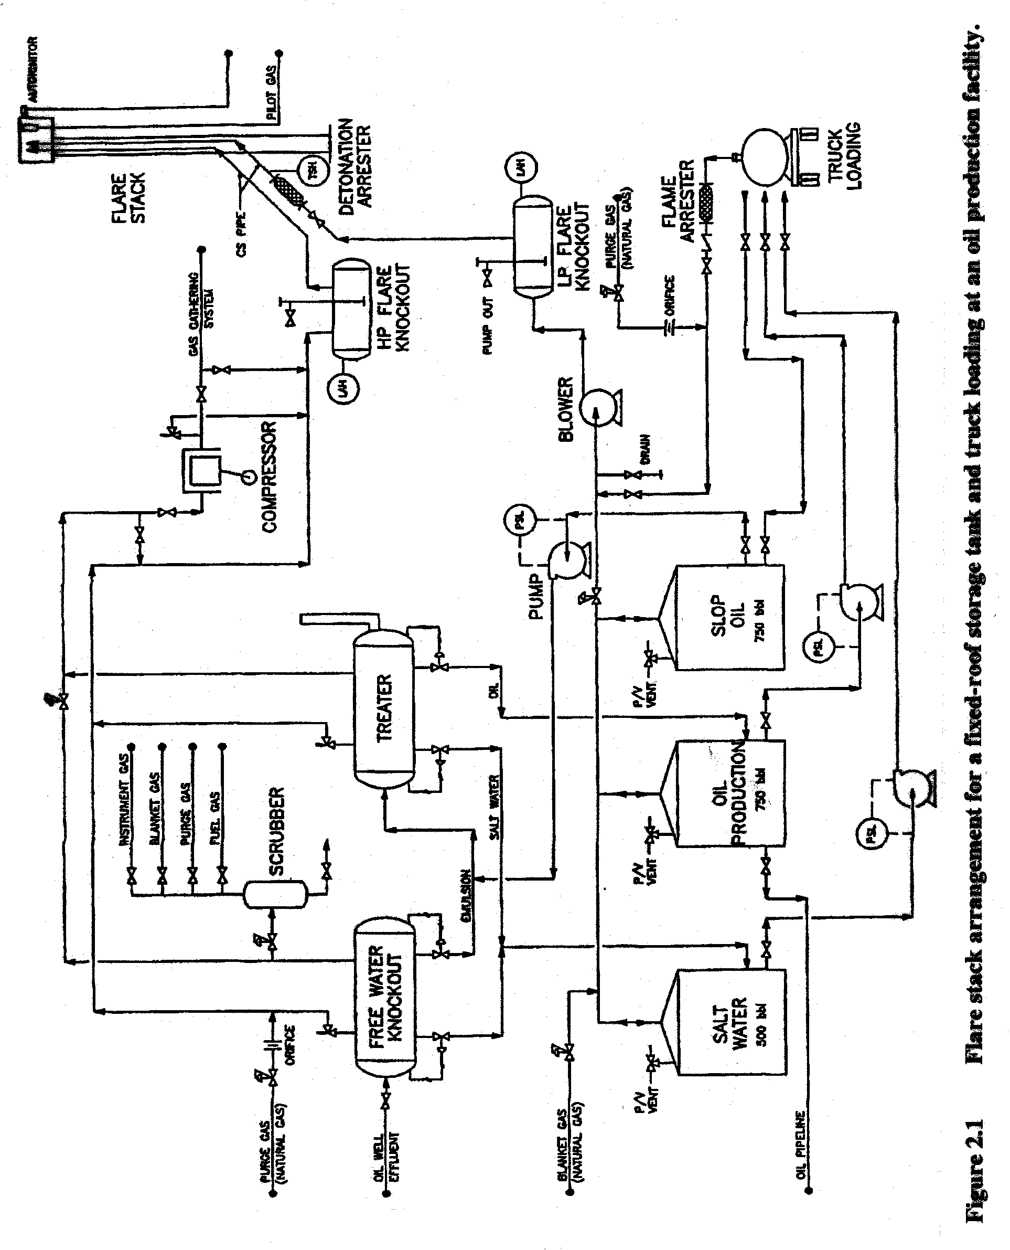

Design of Flare Stack and Accessories

Some of the potential elements of a typical flare system are shown in Figure 2.2.

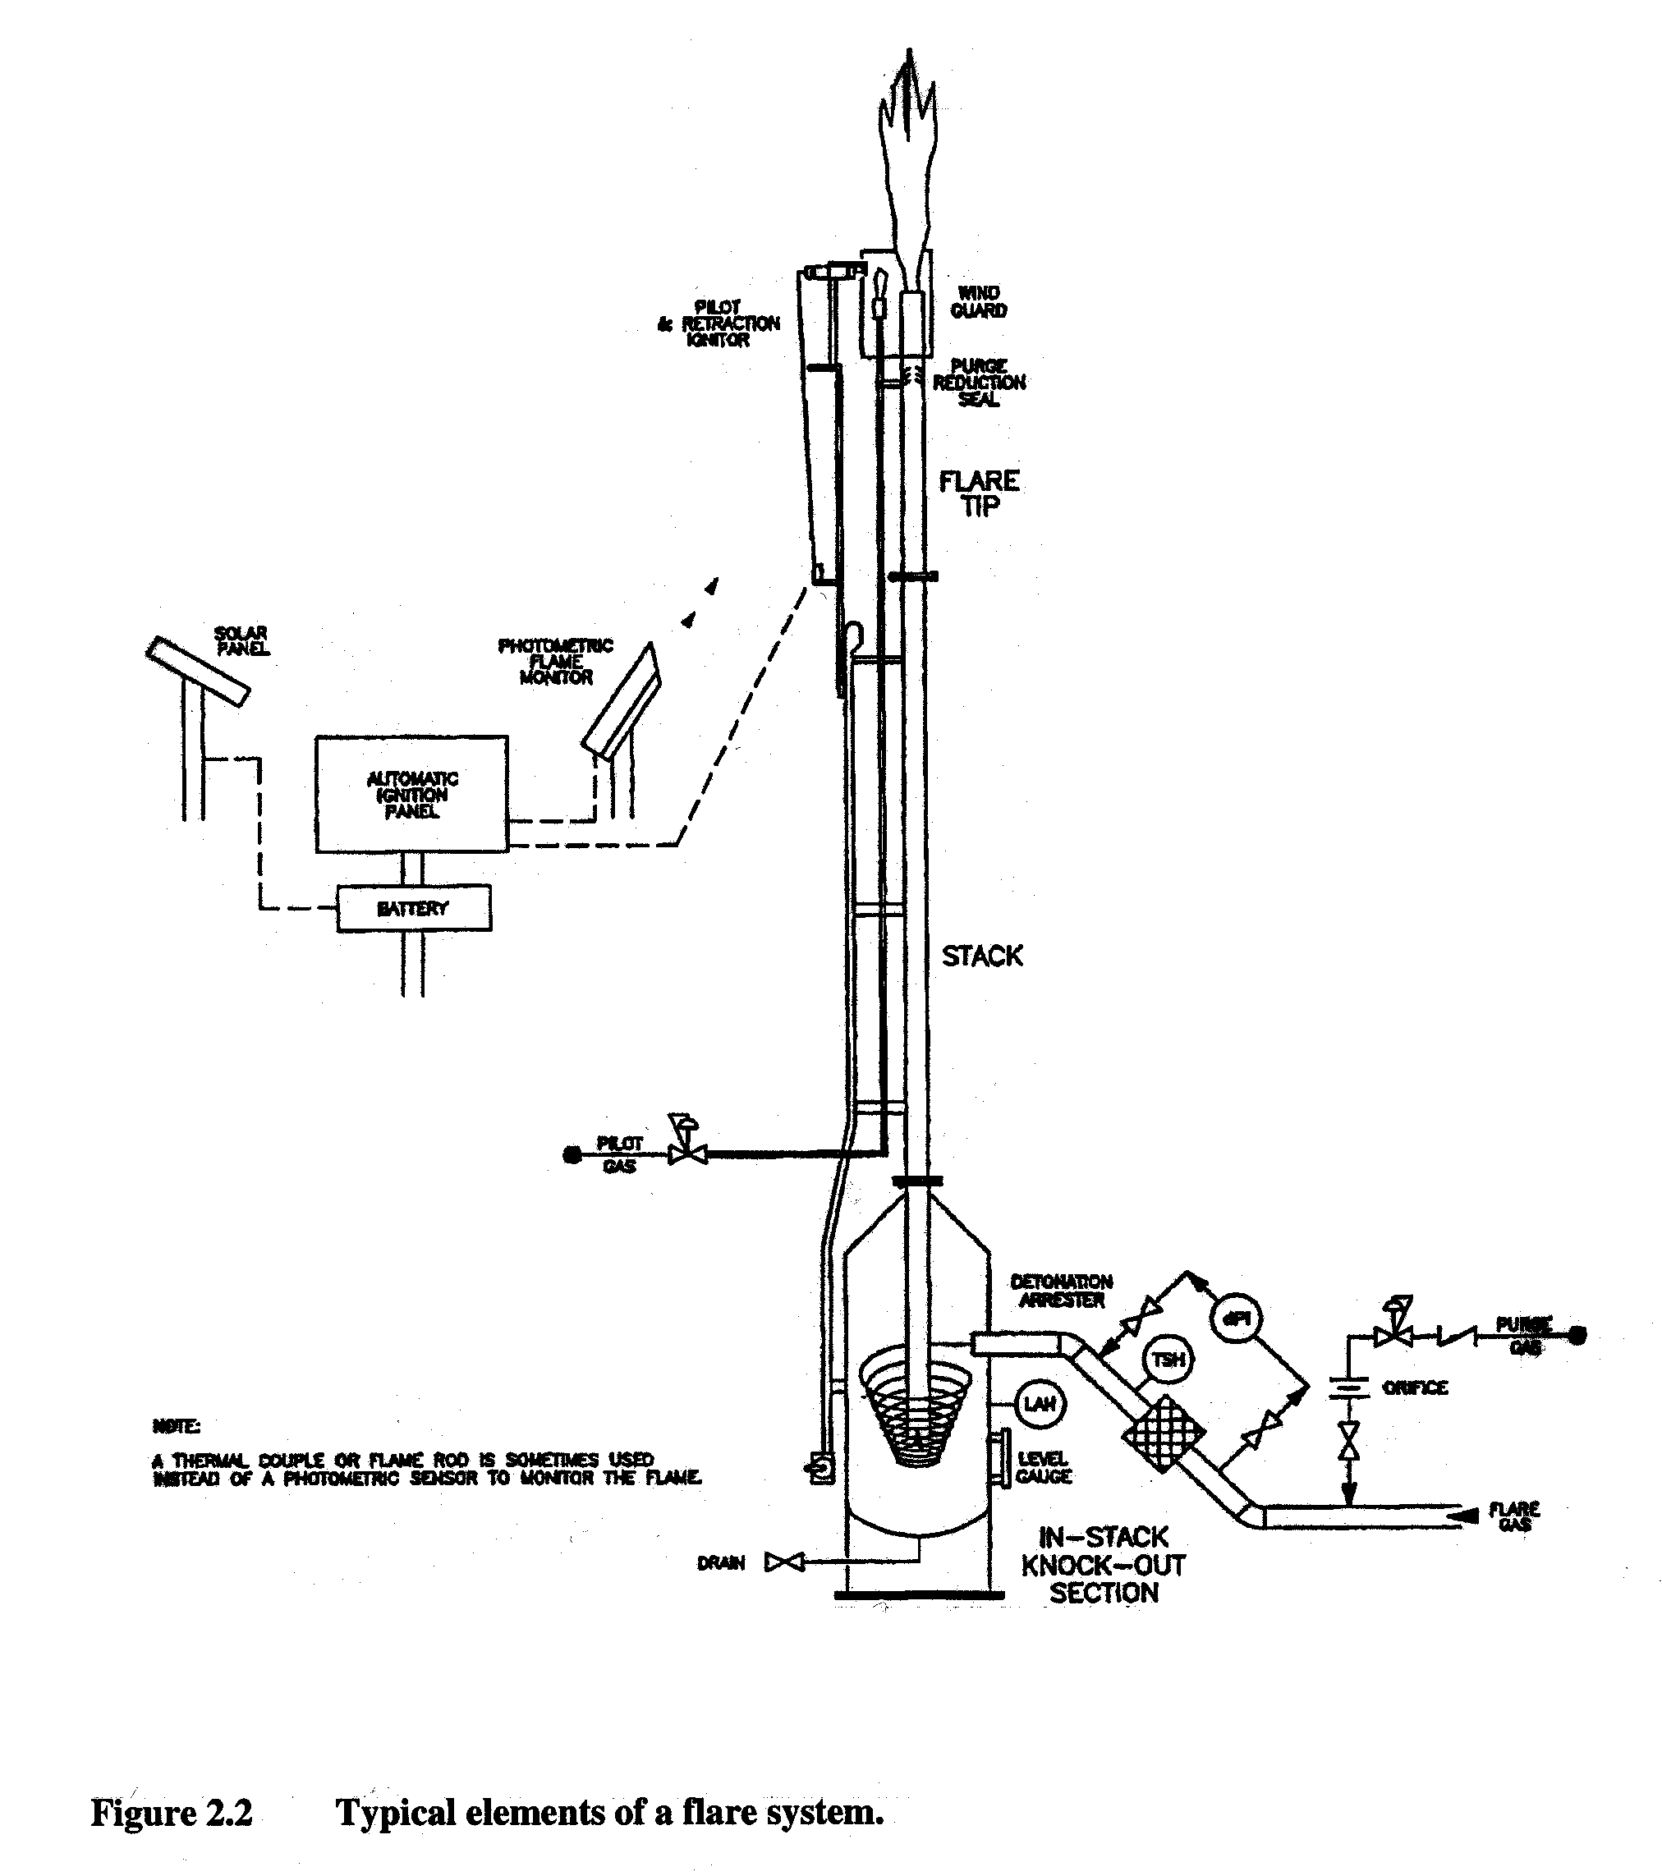

Flare tips should be designed to provide good air/gas mixing. Use of multiple burner arrangements may be considered to achieve more highly aerated flames, which promotes smokeless combustion and improved combustion efficiency. Multiple tips may also be employed to reduce average exit velocities and thereby reduce flare noise and potentially radiant heat (i.e., through reduced flame length). Additionally, air or steam assist may be used to promote improved mixing. However, the latter form of flame assist is usually impractical to provide at oil production facilities. It is possible to quench the flare flame by excessive steam injection.

Ignition System

(a) All continuous flares should be equipped with an auto-ignition system capable of igniting or re-igniting the flare in all weather conditions including winds up to 30 m/s (or 108 km/h). Manual ignition systems should only be acceptable for flares used on manual blowdown or purging systems.

(b) The minimum energy needed for ignition increases with flow velocity and turbulence intensity. It also increases with the molecular weight of the flare gas. The use of a pilot is complementary to, and helps reduce the necessary energizing capacity of an auto ignition system (i.e., the auto-ignition system maintains the pilot while the pilot maintains the main burner flame).

(c) Auto-ignition systems may either be a continuous sparking design or an auto-sparking design with flame failure detection. Flame failure may be detected using thermocouples (flame rods) or photometric sensors. The latter type of sensor is available as either a ground-level or elevated option.

A flare pistol is still an essential item to keep on hand as a contingency measure but should only be used as a last resort and is not a replacement for proper maintenance. The potential for fire hazards should be assessed and appropriate precautionary measures taken before each use of a flare pistol.

Wind guards should be designed to minimize any potential for reduced burner performance.

Flare Stack

- The height should be at least 12 metres and should be sufficient to control thermal radiation and pollutant concentrations at ground level. Radiant heat density at ground level should not exceed 4.73 kW/m².

- If the operational characteristics change significantly (i.e. flow rates or H₂S concentrations), the adequacy of the flare system should be reaffirmed and the nameplate and datasheet information updated as appropriate. Plume and cumulative dispersion modelling should be conducted for all new flares and existing flares to confirm that the resulting maximum ground-level pollutant concentrations meet the applicable ambient air quality objectives.

Knockout Drum

(a) The knockout drum should be sized, designed and operated in accordance with API Recommended Practice 521. It should have:
- provisions for prevention of freezing or exposure to excessive thermal radiation;
- means to indicate the level of liquid in the device and to remove the accumulated liquids;
- a high liquid level sensor which activates an alarm; and
- a high liquid level sensor which actives an emergency shutdown of the facility or otherwise stops flow of liquid to the drum.

(b) In addition, it should be designed for the maximum pressure that may occur due to flow resistance through the system. This may require compliance with the ASME Boiler and Pressure Vessel Code. If the knockout drum is buried, it should comply with EUB Guide G-55.

(c) All lines should be sloped downwards toward the knockout drum.

Flare-Gas Enrichment System

(a) All necessary measures should be taken either to preclude any potential for air-gas mixtures upstream of the flare tip or to ensure enrichment of the flare gas to above 170 percent, by volume, of the upper flammable limit. If used, the enriching system should be located as close as practicable to the vapour source and be designed to promote complete mixing of the gases within 20 pipe diameters of the enriching-gas injection point. To ensure enrichment, the system should either use analyzers to control the amount of enriching gas or use a constant supply of enriching gas that will satisfy all potential situations. In the latter case, the injection rate should be controlled using a fixed orifice for maximum reliability.

(b) Any vapours from tanker trucks, or other potential oxygen-containing vapour mixtures, to be displaced into the flare system should first be enriched as specified above.

Flame and Detonation Arresters

(a) A detonation arrester should be installed downstream of the knockout drum and as close as practicable to the flare inlet wherever an engineering review indicates a reasonable potential for air ingress (e.g. where vapours from storage tanks are directed to the flare). The installation of a detonation arrester should not lessen the need to properly design and maintain flare systems to minimize the risk or air ingress.

(b) A flame arrester normally is not acceptable in these applications due to manufacturer’s restrictions on the maximum allowable distance a flame arrester may be installed upstream of the ignition source (i.e. the flare tip). Where an arrester is used, it should be installed to allow efficient drainage of condensate without impairing its performance. In addition, the arrester should be designed to operate over the full range of gas and ambient temperatures anticipated. This includes provisions against freezing as needed (e.g. providing a heated and insulated enclosure). If frequent fouling is a concern, a spare arrester should be provided in parallel along with adequate valving so each arrester can be isolated and cleaned without the need for a facility shutdown. There should be easy access to service the arresters.

All blowers and fans used to move gases through the flare system should be designed according to the applicable area classification requirements of the Canadian Electrical Code and either be spark resistant or isolated from the gas source by an appropriate flame or detonation arrester.

Other Design Considerations

All laterals from the sub header to the main header or individual safety valves to sub headers should be from above. The laterals should be self-draining without pockets.

The minimum exit velocity should be greater than 1 to 2 m/s to help promote flame stability. The maximum exit velocities for continuous flare systems should not, during routine flaring, exceed a value of 0.2 Mach or such lesser value as may be required to maintain a stable flame. Higher velocities will produce increased flame liftoff and, correspondingly, increased unburned hydrocarbon emissions.

An adequate safety zone should be established around each flare system to avoid potential harm from fire or radiant heat to personnel, equipment and buildings during both normal and emergency or upset flaring conditions.

The procedure to find the heat of radiation and allowable exposure levels for various structures and personnel are detailed in API 521.

Local regulations should also be consulted to determine any additional requirements that may apply in forest areas.

After the stack height has been established from radiation intensity values, the maximum permissible ground level concentration of toxic gases in the event of a flame blowout should be evaluated applying dispersion modelling tools (see Section 9). The concentrations should remain within the Ambient Air Quality Standards given in Table 9.1 or as advised in Section 9.7.

Electrical Requirements

(a) All electrical equipment, fittings and devices must show approval for that use by Canadian Standards Association (CSA). Additionally, the entire flare system shall be electrically grounded and electrically continuous.

(b) Where practicable access to the electric utility grid is unavailable, consideration should be given to use of solar cells and thermoelectric generators to power any electrical instrumentation that may be needed. These power sources are also sometimes used to provide for limited lighting and electrical heat tracing.

The flare system piping and fittings should be in accordance with CSA Z662 at pipeline facilities and with ASME B31.3 at plants for all pressurized portions of the system.

A flare or any other combustion device receiving gas that may condense or freeze at ambient conditions should be designed to preclude any condensation between the knockout drum and the burner tip. Some potential means to help control condensation include:
- minimizing the distance between the knockout drum and the burner tip;
- providing enough heating/pre-heating and insulation to keep the gas above its dewpoint temperature; and
- commingling the waste gas with lighter gas streams (e.g., with associated gas from the inlet separator) to lower the dewpoint temperature of the mixture to below the exit or pre-combustion temperature at the burner-tip.

Flare control panels should be placed at a safe distance away from the base of the stack to protect them from thermal radiation as warranted and to prevent burning in the event a process upset resulting in liquid carry-over through to the flare tip occurs.

Site Operation and Maintenance

To mitigate flare atmospheric impacts, the owner/operator should:
- conduct visual inspections of the flare system as part of normal operator rounds;
- maintain detailed records of these inspections;
- service, repair and replace flaring system components as required and in accordance with the manufacturer’s specifications and recommended procedures; and
- adequately train the facility personnel to operate and maintain the flare system.

Where changes occur in the operation of a flare, operators should re-evaluate the flare design to ensure that it is still suitable for the intended application. Also, existing and proposed solution gas flares should consider the requirements for sulphur recovery and seek relief from these requirements where circumstances may warrant.

Luminosity Control

(a) The occurrence of visible flames may promote negative public reaction in some areas. This may be mitigated through public awareness programs, shielding or enclosure of the flame and/or luminosity control. The amount of luminosity may be reduced by increasing air enrichment in the flame through increased jet velocities or numbers of burners, increased mixing in the flame through air or steam assist or by using premixed air-fuel burner designs.

(b) Most open flares produce a bright yellow flame. This yellow luminosity is usually due to carbon particles (or soot) that form in the flame and radiate strongly at the high combustion temperatures. Sooty flames appreciably increase the radiant heat transfer from the flare causing a reduction in peak flame temperature, and an increase in the required safety zone around the flare.

Solution Gas Flaring

(a) Solution gas is the gas often mixed with oil when oil is removed from the ground. It is a complex mixture of gases containing water and liquid hydrocarbons.

(b) Flaring of solution gas is intended to manage safety concern when the solution gas cannot be conserved or used. Flare systems commonly consist of a flare pipe equipped with a pilot light and ignition system. Solution gas is injected into the air through the flare stack. The flare tip is designed to mix the gas with air to encourage burning and provide a flame over a range of conditions. A series of burners may be used if the gas flow is very variable.

Natural Gas Flaring During Well Testing

(a) Alternatives to flaring such as temporarily tying in the well into an existing raw gas gathering system or reinjection should be considered, if available. Adequate reasons should be provided for considering flaring, if an alternative is available.

(b) During well testing, natural gas can be flared if the gas is:
- low sulphur i.e. less than 1% H₂S; and
- high sulphur i.e. up to 5% H₂S and is discharged into the air through a flare stack that has a minimum height of 12 metres.

(c) Prior to testing, a gas sample analysis should be obtained from the formation to be tested. If a sample is not available, then the operator should conduct a review of similar formations in the region to obtain a representative gas analysis. The sample with the highest concentration of H₂S should be used in the application for permit to operate unless a reasonable argument can be made for using an analysis with a lesser H₂S concentration. The value of the representative sample should be confirmed as soon as possible by conducting a gas sample analysis. This is needed to determine the accuracy of the representative sample used for permitting.

Estimation of Flare Emissions

The owner/operator of the flaring facility can estimate flare emissions of hydrocarbons (VOC and HAP) based on estimates that:

- 2.2% of tank emissions are flared and 2% of flared gases from production sites are unburned; therefore, flare emissions are equal to estimated tank emissions times 4.4 · 10⁻⁴

- emission factor equal to 20 scf of methane per Mcf of flared gas

- in rare cases where flared gas is not ignited by the pilot flame or electronic igniter, the flare will vent temporarily

- tank emissions venting to flares can be estimated by
- direct measurement (stack sampling);
- using AP-42 emission factors published by EPA; and
- applying TANKS4 computer model.

Estimating VOC and HAP emissions from sources venting to flares is based on the gas processing rate and the destruction and removal efficiency of the flare. The following equation can be applied:

E_{x} = Q · y_{x} · 1/C · MW_{x} · (1 – D/100)

where E_{x} = emission estimate of pollutant x, lb/h
Q = gas process rate, scf/h
y_{x} = mole fraction of pollutant x in inlet stream, lb-mole x/lb-mole
C = molar volume of ideal gas, 379 scf/lb-mole
MW_{x} = molecular weight of pollutant x
D = destruction and removal efficiency, %

Gas Sweetening Plant Flaring

When flaring or incineration is practiced at gas sweetening plants, the major pollutant of concern is SO₂. Most plants employ elevated smokeless flares or tail gas incinerators for complete combustion of all waste gas constituents including virtually 100% conversion of H₂S to SO₂. Small particulate, smoke or hydrocarbons result from these devices, and because gas temperatures do not usually exceed 650ºC (1200ºF), significant quantities of nitrogen oxides are not formed.

2.7.2 Emission factors for gas sweetening plants with smokeless flares or incinerators are presented in Table 2.1. Factors are expressed in units of kilograms per 1000 cubic metres (kg/10³ m³) and pounds per million standard cubic feet (lb/10⁶ scf).

Table 2.1 Emission Factors for Gas Sweetening Plants ª

Process ^{b} | Particulate | SO₂^{c} | CO | Hydro-  carbons | NO_{x}
Amine  kg/10⁶ m³ gas processed  lb/10⁶ scf gas processed | Neg  Neg | 26.98 S ^{d}  1685 S ^{d} | Neg  Neg | Neg ^{e}  Neg ^{e} | Neg  Neg

Neg = Negligible
ª Factors are presented only for smokeless flares and tail gas incinerators on the amine gas sweetening process with no sulphur recovery or sulphuric acid production present. Too little information exists to characterize emissions from older, less-efficient waste gas flares on the amine process or from other, less common gas sweetening processes.
^{b} Factors are for emissions after smokeless flares (with fuel gas and steam injection) or tail gas incinerators.
^{c} Assumes that 100% of the H₂S in the acid gas stream is converted to SO₂ during flaring or incineration and that the sweetening process removes 100% of the H₂S in the feedstock.
^{d} S is the H₂S content of the sour gas entering the gas sweetening plant, in mole or volume percent. For example, if the H₂S content is 2%, the emission factor would be 26.98 times 2, or 54.0 kg/1000 m³ (3370 lb/10⁶ scf) of sour gas processed. Note: If H₂S contents are reported in ppm or grains (gr) per 100 scf, use the following factors to convert to mole %:
10,000 ppm H₂S = 1 mole % H₂S
627 gr H₂S/100 scf = 1 mole % H₂S
The m³ or scf are to be measured at 60ºF and 760 mm Hg for this application (1 lb-mol = 379.5 scf).
^{e} Flare or incinerator stack gases are expected to have negligible hydrocarbon emissions. To estimate fugitive hydrocarbon emissions from leaking compressor seals, valves, and flanges, see Section 4.

Approval, Notification and Reporting

Flaring approval should be obtained from the appropriate regulatory authority. Approvals would most likely be part of Land Use Permit or Water License. The approval application process would have similar elements as those listed in Guide 60: Upstream Petroleum Industry Flaring Guide of EUB enclosed as Appendix A.

An owner or operator should notify the regulatory authority 24 hours prior to planned flaring and immediately for emergency flaring. Required information should include notification date, time, location, operating company, contact name and telephone number, flaring commencement time, duration, rate, total volume, percentage H₂S and reason for flaring.

A report of the flaring and monitoring operations should be submitted to the regulatory authority within three weeks of the flaring completion date. The report should include:
- H₂S and SO₂ concentrations;
- the actual volume of gas flared;
- maximum and average flow rates;
- wind speed and direction; and
- dates and times monitoring occurred.

When measurement does not occur on all streams, engineering estimates must be used to report any flared gas not measured.

Upon request by the regulatory authority, all operators should be able to provide a documented system for flare measurement and/or flare estimation. Operators must also be able to provide, upon request, information on flaring and related public complaints.

The regulatory authority may require operators, on the basis of audit and inspections, to examine flare fuel gas use in cases where it appears that fuel gas use is excessive. An operator could use an engineering estimate to determine the split between residue fuel gas (processed gas) and overhead fuel gas (gas from plant vessels). Excessive fuel gas use in the flare for flare pilots and purge gas can contribute significantly to fuel use.

Additional Information

For additional information, the owner/operator should refer to enclosed (Appendix A) Guide 60: Upstream Petroleum Industry Flaring Guide published by Alberta Energy and Utilities Board in July 1999. Prior to implementing any recommendations given in Guide 60, the owner/operator should obtain approval from the regulatory authority.

FUGITIVE EMISSIONS

Introduction

Fugitive emission refers to release of gaseous substances such as hydrocarbon vapours from oil and gas production and processing equipment and evaporation of hydrocarbons from open areas, rather than through a stack or vent. Fugitive emission sources include valves of all types, flanges, pump and compressor seals, process drains, cooling towers and oil/water separators. Agitator seals are to be treated as pump seals using similar emission factors. Connections to equipment or piping other than flanges would be threaded fittings and compression couplings. Open-ended lines should be closed by a terminal valve or a blind flange or otherwise plugged. Sampling connection systems should have closed purge or closed vent systems.

Fugitive emissions are attributable to the evaporation of leaked or spilled petroleum liquids and gases. Normally, control of fugitive emissions involves minimizing leaks and spills through equipment changes, procedure changes and improved monitoring, housekeeping, and maintenance practices. Controlled and uncontrolled fugitive emission factors for the following sources are listed in Table 3.1.

Table 3.1 Fugitive Emission Factors for Oil and Gas Facilities

Component Type | Facility Type
Component Type | Production Field |  | Gas Processing Plant
Component Type | THC, lb/day | ROC/THC Ratio | THC, lb/day | ROC/THC Ratio
Gas/Condensate Service  Valve  Connector  Compressor Seal  Pump Seal  Pressure Relief Valve | 0.295  0.070  2.143  1.123  6.670 | 0.31  0.31  0.31  0.31  0.31 | 1.0580  0.0580  10.7940  3.3000  9.9470 | 0.38  0.43  0.20  0.79  0.07
Oil Service  Valve  Connection  Pump Seal  Pressure Relief | 0.0041  0.0020  0.0039  0.2670 | 0.56  0.56  0.56  0.56 | 0.4306  0.0694  1.3080  1.7400 | 0.33  0.33  0.33  0.33

Notes: THC, lb/day = total hydrocarbons (including methane and ethane), pounds per day
ROC = reactive organic compounds (non-methane, non-ethane)

Fugitive emissions released through a stack, duct or other confined controlled enclosure or sources controlled by specific equipment as well as area sources are not covered by this Air Quality Code of Practice.

A leak in this Code is defined as the detection of a VOC concentration of 10,000 ppmv or more at the emission source using a hydrocarbon analyzer according to EPA Method 21 (see Section 8) or equivalent. It can become more stringent over time and may vary for different equipment components.

Equipment carrying VOC streams should be monitored. VOC streams are process streams containing at least 10 % VOC by volume.

The primary objective of the Code is the reduction of fugitive VOC emissions. It is appropriate that priorities be given to the most cost-effective alternatives available for meeting the objective.

Fugitive Emissions Estimate Methodology

Depending on the required accuracy of fugitive emissions estimate and availability of information, the owner/operator of an oil/gas facility estimates equipment leaks from a specific production/processing unit by:
- average emission factor method;
- leak/no-leak emission factor method (screening ranges approach);
- application of EPA corrections; and
- development of unit-specific correlations.

Details of each of the above method are provided in Appendix C Protocol for Equipment Leak Emission Estimates.

Steps to calculate fugitive emissions:

- Identify all the refinery processes where gaseous/volatile substances are present.

- Define precisely the process unit boundaries. The exact basis for the unit definition should be documented. A simplified facility process flow diagram can usually provide the basis for segregating a facility into process blocks or units.

- On the flow diagram identify the major process streams (leakpaths) entering and leaving the process unit. The actual screening and data collection can be done most systematically by following each stream. In each process stream within a unit boundary determine the number of fugitive emission components that are in the different service types (valves, flanges, connectors, pressure relief valves, etc.) - refer to leakpath component counting guide (Table 3.2).

Table 3.2 Leakpath Component Counting Guide

Component Type | Number of Associated Leakpaths
Flanges and Connections | Each flange or threaded connection shall be counted as 1 connection. Valve bonnets and flanges shall be counted as connections. Connections and flanges associated with compressors, pumps, relief devices and sight glasses should be counted as connections.
Valves | Each valve shall be counted as having 1 valve stem and three associated connections (Valve bonnet and two flange or threaded connections). Low emitting or bellows stem valves should be listed separately.
Pump Seals | Each pumping device shall be counted as a separate pump seal on pumps utilizing a common driver. Pumps equipped with tandem or dual mechanical seals should be listed separately.
Compressor Seals | Each compressor cylinder shall be counted as a separate compressor seal on multiple cylinder compressors. Compressor seals that are vented to vapour recovery should be listed separately.
Open Ended Lines | Open ended lines should be sealed with a plug or with two closed valves. However, each leakpath associated with sealed open ended lines should be counted consistent with the leakpaths "valves" and "connections" above up to and including the second valve stem.
Pressure Relief Device | Each pressure relief device (PRD) not equipped with or vented to an emission control device shall be counted as 1 PRD. PRDs vented to control devices or equipped with rupture disks should be listed separately.

- Once all the fugitive emission components along the major streams have been screened, the unit should be divided into a grid to identify stream properties such as the individual stream compositions containing fugitive substances, the type of substance (gas, light liquid or heavy liquid), total time of operation of the process unit in the time under consideration (month, quarter, year) and other associated activities. Ideally, a chemical analysis of the stream should be conducted, but this is often unrealistic. Other sources of stream composition information are operating personnel, crude or feedstock assays, product specifications and speciation profiles. In the absence of the site specific information, some general guidance on the types and chemical composition for a process unit input and output streams can be based upon the unit purpose and operating conditions

- Calculate fugitive emissions (FE) for each equipment type using the equation:

FE = A ∙ AAF ∙ N ∙ WF

where: A = activity rate (hours of operation)
AAF = applicable emission factor for the equipment type
N = number of pieces of equipment of the applicable equipment type in the stream
WF = average weight fraction of the fugitive substance in the stream

Above equation may be used several times for the same equipment type for different concentrations. Alternatively, weighted average concentration may be calculated from the A and WF values and used in one calculation.

Fugitive emissions can be estimated using the exact screening values (SV) recorded for each component. These concentration values are then converted into an equivalent emission rate using a correlation or equation shown in Table 3.3. More details concerning fugitive emission correlations are provided in Appendix C.

Table 3.3 Screening Value Range Emission Factors

Equipment Type | Correlation
Gas valves | Leak rate (kg/h) = 1.87 x 10 ⁻ ⁶ (SV) ^{0.873}
Light liquid valves | Leak rate (kg/h) = 6.41 x 10 ⁻ ⁶ (SV) ^{0.797}
Light liquid pumps | Leak rate (kg/h) = 1.90 x 10 ⁻ ⁵ (SV) ^{0.824}
Connectors | Leak rate (kg/h) = 3.05 x 10 ⁻ ⁶ (SV) ^{0.885}

Calculate total annual fugitive emissions of a particular substance for all types of equipment and report to the regulatory authority following appropriate protocols.

All major, critical, inaccessible and unsafe to monitor components, except fittings, should be clearly identified in diagrams for inspection, repair, replacement and record keeping purposes as approved by the regulatory authority.

Area Leak Rate Measurement

There may be some instances where a whole process area may be monitored for leakage and when no leakage is observed, all of the contained equipment and components therein can be rated as non-leaking. It is also feasible to rigorously control some process area ventilation systems and to organize specific exhaust streams to monitor the flow and composition of those streams to allow calculation of total mass emission rates. Continuous emission monitoring of a process area or a building is preferred over attempting bagging or once-only isolation and measurement.

Equipment carrying VOC streams should be monitored. VOC streams are process streams containing at least 10% VOC by volume.

Leak detection and repair (LDAR) will be applied to pipe sizes greater than, or equal, to 1.875 cm nominal diameter (¾ inch).

Exemptions:
- Components that are inaccessible;
- Valves less than ¾" or 1.875 cm nominal size;
- Valves that are not externally regulated (i.e. check valves);
- Components that are of leakless design (i.e. sealless pumps, bellow seal valves, pumps with double mechanical seals and a barrier fluid at higher pressure than operating pump pressure);
- Open-ended lines equipped with a cap, blind, flange, plug or second valve;
- Pressure relief valves, pumps and compressors that are equipped with a closed-vent system capable of capturing and transporting any leak to a vapour control system;
- Components exclusively handling commercial natural gas;
- Components buried below ground;
- Components, except those at gas processing plants, exclusively handling fluids with a volatile organic compound concentration of 10 percent by weight or less or components exclusively handling liquids, if the weight percent evaporated is 10 percent or less at 150ºC (302ºF);
- Components at oil and gas production facilities handling liquids of less than 30 degree API gravity that are located after the point of primary separation of oil and gas provided the separation vessel is equipped with a vapour recovery system and the pressure of the fluid is at atmospheric; and
- Components incorporated in lines operating exclusively under negative pressure.

The owner or operator should develop a plan for fugitive VOC emissions (FVE) reduction for approval six months after notification by the regulatory authority.

The owner/operator of a plant site may divide the plant site into manageable, distinct entities for the purpose of LDAR program implementation, management and reporting.

Oil Wellhead Fugitive Emissions

Oil wellheads are the aboveground extension of oil wells where production control and measurement facilities are located. Potential leak sources of a typical oil wellhead are assumed to be valves, flanges, small pipe connections and a polished rod stuffing box. Typical wellhead with identified potential leaks components is shown in Figure 3.1.

For light crude wellheads (API gravity above 20°), the emission factor is estimated to be 16.6 scf per well per day (source: the API No. 4638 Workbook).

Separators, Heater Treaters, and Header Fugitive Emissions

Additional sources of fugitive emissions in the production sector are: separators that separate oil, gas and water; heater treaters that separate crude oil and water; and, headers that are collection points for oil or gas gathering lines. The operator should make every effort to minimize emissions through implementation of strategies such as pollution prevention, best management practices, and emission control technologies.

Fugitive emissions from these sources, based on component leak rates from the API 4638 Workbook and average component numbers for each of the three sources, varied from near zero to 0.59 scf per source.

Drilling Fugitive Emissions

No data for methane losses during oil well drilling operations have been identified. No emissions will occur until a hydrocarbon bearing formation is entered, at which point most emissions will be vented rather than fugitive.

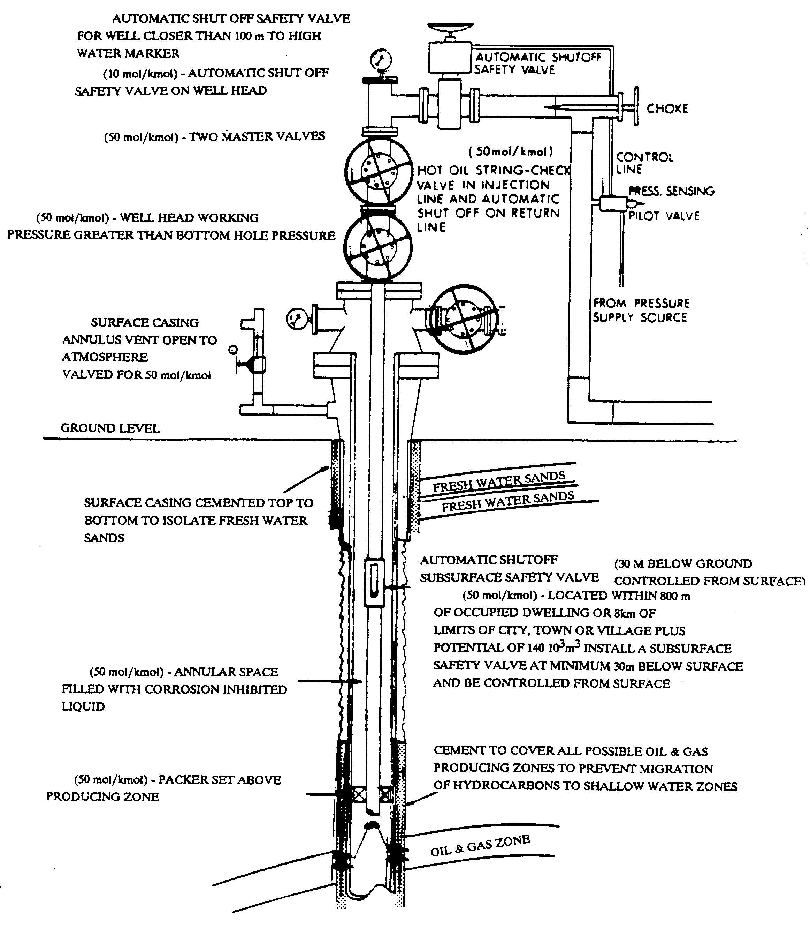
Figure 3.1 Oil wellhead with identified potential fugitive emission sources.

Leak Detection and Repair

Leak detection and repair (LDAR) is required:

- Quarterly for compressor seals and annually for all the other components.

(b) Immediately after repair for any component that was found to be leaking.

(c) Within 24 hours for a pressure relief valve that has been vented to the atmosphere.

The leak frequency should not be more than 2% for any group of components monitored, excluding the category pumps/compressors.

The leak frequency of pumps/compressors should be less than 10% of the total number of pumps/compressors or three (3) pumps/compressors, whichever is greater.

If the leak frequency for a component (e.g. flanges) is less than 2% in two or more successive required LDARs monitoring, a statistical sampling method for that component, as approved by the regulatory authority, may be used to demonstrate that the component is in compliance with the 2% leak frequency.

The repair of leaks found during monitoring should start within 5 working days and complete within 15 working days unless a plant shutdown is required or the number of components requiring repair is beyond the current capability of the maintenance resources (a record of these exceptions and when they were corrected should be maintained).

All components subject to leak repair should be reinspected within one week of repairs.

Components, which cannot be repaired without a unit shutdown, should be identified and the repair planned for the next shutdown.

Compliance

The owner/operator should maintain an inventory of sources and total emissions based upon the methodology in Section 3.2 of this Code. The inventory should be available for review by the regulatory authority.

The results of emissions monitoring and evaluation should be reported to the regulatory authority in a pre-approved format.

Non-Compliance

When the leak detection and repair program is not met, the owner/operator should repeat a full monitoring survey of all component sources at the next leak detection cycle.

In the case where two consecutive full monitoring cycles (after the agreed upon compliance deadline) fail to show a leak frequency of 2% or less for components excluding the category of pumps/compressors, the regulatory authority may require the implementation of a Quality Improvement Program (QIP) for those categories of components not in compliance.

For the category pumps/compressors, if the leak frequency is greater than 10% of the total number of pumps/compressors or three (3) pumps/compressors, whichever is greater, the regulatory authority may require the implementation of a Quality Improvement Program (QIP).

Any liquid leak or gas leak of over 50,000 ppm detected by the authorized inspector should be considered as non-compliance.

Any major gas leak detected by the authorized inspector, within any continuous 24-hour period, and numbering in excess of the Leak Thresholds for that component listed below in Table 3.4, may constitute non-compliance.

Table 3.4 Leak Thresholds

Component | Max. No. of Leaks
Component | < 200 components inspected | > 200 components inspected
Valves  Pumps  Compressors  PRDs  Other Components | 1  2  1  1  1 | 0.5% of number inspected  1% of number inspected  1  1  1

The maximum number of leaks in Table 3.4 shall be rounded upwards to the nearest integer, where required.

Record Keeping

Records are to be kept for at least three years or as required in a form easily accessible by the regulatory authority.

Records should identify all components sampled, leaking or non-leaking, provide measurement details and document repair and replacement activities for leakers. This requirement will serve as a baseline for the total plant fugitive VOC emissions estimate.

The method of data preparation and tools for storing field information from equipment monitoring will be the sole responsibility of the owner/operator.

Reporting

Reporting for compliance with performance guidelines should be done according to the requirements of the regulatory authority with a uniform reporting format.

The report and attachments submitted to the regulatory authority shall be available to the public.

Annual reports should be submitted to the regulatory authority by a date as specified by the regulatory authority.

Quality Management

Consideration should be given to a total quality management program which includes:
- identification of poor performing equipment and prompt repair and replacement of these units;
- an ongoing review and analysis of available technology;
- in-plant performance trials;
- frequent inspection of control valves, pumps and compressor seals; and
- screening of equipment that has been taken out of service as it is returned to service.

Records should be kept that identify all components sampled and provide measurement details for those found to be leaking. Records should document repair and replacement activities for leakers.

Operating Practices

The owner/operator should consider the use of best available technology when replacing components in high leak frequency service.

The emphasis on fugitive VOC emissions (FVE) reduction should be on high leakers as a priority with a concerted effort to reduce those to an acceptable level.

Equipment should be monitored by trained personnel.

FVE should be measured recognizing the difficulties associated with weather conditions.

Equipment monitoring should be carried out with an understanding of the variables associated with leak detection.

Additional Information

Additional information concerning fugitive emissions estimation methods and emission factors for fugitive leaks can be found in:

(a) Protocol for Equipment Leak Emission Estimates EPA-453/R-95-017, November 1995, enclosed as Appendix C.

(b) Protocol for Equipment Leak Emission Estimates EPA-453/R-95-017: appendices, examples of calculations available at www.epa.gov/ttn/chief/efdocs/lks95_ap.pdf.

(c) CCME Environmental Code of Practice for the Measurement and Control of Fugitive VOC Emissions from Equipment Leaks. Pub. No: PN1106, October 1993.

PIPELINE EMISSIONS

Introduction

Air emission sources of oil and gas transmission and distribution sectors include fugitive pipeline leaks, vents from pressure relief valves and pipeline compressor gas turbines. Natural gas pipelines are sources of VOC, HAP and hydrocarbons contained in the material. The natural gas turbines driving compressors at the stations also contribute to overall pipeline system emissions. Despite the advantages of gas-fired generation, turbine emissions remain a concern for both air quality regulators and pipeline operators. Pipeline compressor gas turbines operate in simple cycle and cannot use exhaust cleanup systems. As a result, they cannot achieve near-zero emissions and operators are often required to install more expensive electric motor drives in emissions sensitive areas. Small amounts of natural gas are also emitted at the pipeline station sites from equipment and instrument vents.

Pigging operations are a potential source of VOC, HAP and hydrocarbon emissions if residual vapours are vented to the atmosphere rather than to a flare or incinerator. As the pig travels through the pipeline, residual vapours are pushed through the line as well. If the vapours are not routed to a control device, they escape through openings on the device such as hatches, doors or vents. Emissions can be significant depending on the amount and vapours pressure of the product. Depending on the gas used to push the pig, the bleed-off step can also result in emissions if the gas is not vented to a control device.

Facility Design

To assure no leak operation, the pipeline system should be designed and constructed up to relevant standards, guidelines and specifications, including CSA Standard Z662.

Instrumentation and control system should be in place to monitor process conditions and to detect the presence of fire, fumes, vapours or natural gas. In remote operations, the automatic system should shut down the station without human intervention. At staffed sites, a shut down should also be initiated by emergency shutdown pushbuttons located throughout the site.

For a new development, the minimum setback for a sour pipeline, based on a H₂S release level, should follow the following guidelines:

- For level 1 (release volume < 300 m³ or release rate < 0.3 m³/s) – 100 m.

- For level 2 (release volume 300-2000 m³ or release rate 0.3-2 m³/s) – 100 m for individual buildings and 500 m for urban centres or public facilities.

- For level 3 (release volume 2000-6000 m³ or release rate 2-6 m³/s) – 100 m for individual buildings, 500 m for unrestricted rural development and 1,500 m for urban centres or public facilities.

- For level 4 (release volume > 6000 m³ or release rate > 6 m³/s) – distances specified by the authorized representative of the GNWT but not less than in corresponding level 3 circumstances.

A sour pipeline should have check and block valves so located that the release of H₂S will remain within acceptable limits in the event of a leak.

A sour pipeline should include emergency shut down devices that close on the failure of any control or operating component.

Signs should be posted at all sour pipeline facilities warning of the possible presence of H₂S and advising of protective gear requirements.

Open-ended lines and valves located at the end of pipelines should be sealed with a blind flange, plug, cap or a second closed valve at all times except during operation. Operation includes draining or degassing operations, connection of temporary process equipment, sampling of process streams, emergency venting and other normal operational needs.

Pipeline supports should be designed to support the pipe without causing excessive local stresses and without imposing excessive axial or lateral friction forces that might prevent the desired freedom of movement and could result in cracks leading to emissions.

Design of transmission and distribution sectors with regards to emission mitigation should consider the following:
- using fixed/portable compressors for pipeline pumpdown;
- installing vapour/fuel recovery systems;
- replacing wet gas seals with dry seals;
- monitoring/replacing compressor rod packing systems; and
- re-routing glycol skimmer gas.

A Memorandum of Understanding (MOU) for the Harmonization for Oil and Gas Pipelines has been signed between the Governments of NWT and Alberta. The owner or operator of a gas/oil facility may approach the regulatory authority for detailed information on the MOU pertaining to air quality.

For other aspects of Air Quality Code of Practice with respect to sour pipeline design and operation, the owner or operator might refer to B.C. Reg. 359/98 M349/98 Sour Pipeline Regulation under Pipeline Act included in Appendix B for further guidelines.

Site Operation and Maintenance

The operator should:

- Include pipeline break detection and emission control equipment in designing of a new facility or upgrading the existing one.

- Have in place pipeline leak or line-break detection and troubleshooting system.

- Prepare and implement pipeline leak detection and fugitive emissions monitoring program.

- Modify such program from time to time as experience dictates and as changes in operating conditions require.

- In addition to being concerned about leaks and line breaks, pipeline operator should focus on limiting harmful exhaust emissions from compressor engines.

- Obtain component inventory of pipeline facilities and auxiliary equipment.

- Develop and maintain, with necessary updating, an emergency response manual that has the approval of the chief inspecting engineer.

Inspections

Pressure control, pressure limiting and pressure-relieving systems (or devices) should be inspected at least once per calendar year. Records of such tests and inspections and the records of any corrective action taken should be retained by the operating company.

Any annual inspection frequency listed in Section 4.4.1 should revert to the inspection frequencies specified by the regulatory authority should any liquid leaks and major gas leaks exceed 0.5 percent of the total components inspected per inspection period.

All leaking components should be affixed with brightly coloured, weatherproof tags showing the date of leak detection. The tags should remain in place until the components are repaired and reinspected.

A pressure relief valve should be inspected according to EPA Reference Method 21 within 3 calendar days after every pressure relief.

The operator should maintain an up-to-date leaks inspection log containing, at a minimum, the following:
  - name, location, type of components, and description of any unit where leaking components are found;
  - date of leak detection, emission level (ppm) of leak, and method of leak detection;
  - date and emission level of re-check after leak is repaired; and
  - total number of components inspected, and total number and percentage of leaking components found by component types.

Detection and Emergency Response

Leak detection systems should be tested annually to demonstrate continued effectiveness.

A leak identified by Section 4.5.1 should be any fluid leak, a visual or audible vapour leak, the presence of bubbles using soap solutions or a leak identified by the use of a vapour analyzer.

Any vapour leak identified during the inspection of components should be measured to quantify emission concentrations according to EPA Reference Method 21 or equivalent.

The owner/operator of a pipeline transporting HVP liquids should periodically conduct emergency exercises (simulation leaks) structured to test the licensee’s internal capabilities for initial response to the emergency procedures described in its emergency procedures manual (see Section 4.3.g) and to test any leak detection and supervisory control and data acquisition systems associated with the pipeline.

Pipeline valves that might be required during an emergency should be inspected and partially operated at least once per calendar year.

The operator should maintain failure/repair record of the pipeline system.

An emergency planning zone should be maintained for each sour pipeline. The emergency planning zone of a sour pipeline is the area within a parameter formed by using the hydrogen sulphide release rate in metres per second or volume in cubic metres for the sour pipeline and finding the corresponding distance in kilometres using the graphs set out in the BC Sour Pipeline Regulation (ref: Appendix B).

Leaks from components should be immediately minimized to the extent possible to stop or reduce leakage to the atmosphere.

All leaks should be minimized to the extent possible and should be replaced with Best Available Control Technology (BACT) equipment within one year or during the next process unit shutdown, not to exceed two (2) years.

Any repaired or replaced component should be re-inspected in accordance with EPA Method 21 by the operator within 30 days of the repair or replacement.

Notification

The owner or operator should report a leak or break to the 24-Hour Spill Report Line, and to the regulatory authority. The NEB should be notified if there is any contact damage. The Spill Line shall be notified if there is a reasonable likelihood of a spill. The NWT Spill Contingency Planning and Reporting Regulations should be used as an oil spill reference.

Estimation of Pipeline Emissions

Fugitive Emission Factors is an alternative method of total hydrocarbons (THC) emissions estimation (see Section 3).

- The fugitive emission factors for oil pipelines reported by PSI (Pipeline Seal & Insulator, Inc., Houston, TX) is estimated to be 25 scf of petroleum hydrocarbons per pipeline-mile per year. Total annual oil pipeline emissions in scf would be 25 times total length of the pipeline.

- Fugitive emissions for pumping stations from potentially leaking equipment components such as valves, fittings, pumps, compressors, connectors, can be calculated in the following steps:
  - obtain detailed component counts for each facility;
  - determine service type (gas/condensate or oil) for each component; and
  - calculate total hydrocarbon emissions in lb/day by multiplying the number of specific component types by a relevant THC emission factor (EF) listed in Table 4.1.

Table 4.1 Fugitive Emission Factors for Production Fields

Component Type | Emission Factor EF  lb/day
Gas/Condensate Service
Valve  Connection  Compressor Seal  Pump Seal  Pressure Relief Device | 0.295  0.070  2.143  1.123  6.670
Oil Service
Valve  Connection  Pump Seal  Pressure Relief Device | 0.0041  0.0020  0.0039  0.2670

  - where applicable, reduce uncontrolled emissions generated in step above by the emission reduction factors (fraction of Control Efficiency) given in Table 4.2.

Table 4.2 Emission Reduction Factors

Leak Path Type | Control Measure | Control Efficiency, %
Valve  Valve  Valve  Compressor Seal  Pump Seal  Pressure Relief Device  All  Other | Bellow design  Monthly monitoring  Low emission stem packing  Vented to Vapour Recovery System  Dual/tandem seal  Vent to VRS or equip with rupture disk  Maintain at no detectable emission  Proposed by operator | 100  84  Determined by supplier  100  100  100  100  Determined by supplier

Emissions Screening Procedure, which gives higher accuracy of emission estimates than emission factor method, uses screening values and correlation equations. To implement this method, the owner/operator shall carry out the following tasks:

- Measure concentrations of hydrocarbons around components with portable hydrocarbon detection analyzer (FID) type, calibrated and certified.

- Measure background concentrations and deduct them from concentrations recorded in Section 4.7.2 (a).

- Calculate total hydrocarbon emissions in lb/day by multiplying screening value (SV, ppmv) by relevant correlation equation listed in Table 4.3.

Table 4.3 EPA Correlation Equations (lb/day)

Component | Correlation Equation*
Threaded Connections  Flange  Valve  Open-end  Pump Seal  Other | 7.99 x 10⁻⁵ (SV)^{0.735}  2.35 x 10⁻⁴ (SV)^{0.703}  1.21 x 10⁻⁴ (SV)^{0.746}  1.14 x 10⁻⁴ (SV)^{0.704}  2.55 x 10⁻³ (SV)^{0.610}  6.98 x 10⁻⁴ (SV)^{0.589}
* Source: US EPA Protocol for Equipment Leak Emission Estimates EPA-453/R-95-017

- Summarize total hydrocarbon releases by adding releases from all fittings in each class of components providing that all were screened for SV.

Methane leakage rates from crude pipelines are estimated to be essentially zero, since crude is nearly totally degassed in storage tanks and any crude leaks from production area piping are quickly repaired.

Stationary Combustion Turbine Emissions

The owner or operator should develop and operate various types of combustion turbines driving gas compressors or oil pumps in a manner that restricts emissions of nitrogen oxides (NO_{x}), sulphur dioxide (SO₂) and carbon monoxide (CO) with emission targets specified by CCME in National Emission Guidelines for Stationary Combustion Turbines.

In the case where multiple new small combustion turbines are installed instead of a single large unit, the applicable unit size for the purposes of this Guideline will be the sum of the individual unit power ratings. While it is recognized that operational requirements may dictate the use of several units, multiple small units should not be used to evade the more stringent limits applicable to larger units.

In the case where a combustion turbine facility uses auxiliary burners, the Guideline limits apply to all fuel consumed by the facility, the fuel used in the auxiliary burners being treated as if it had been burned in the combustion turbine.

To determine the useful energy output over and above electrical or shaft power production, it is only necessary to measure the difference between the energy of the thermal fluids leaving and returning to the combustion turbine facility and to demonstrate that the bulk of this energy is extracted in a useful application. This avoids the need to individually measure the energy consumed by each downstream thermal energy application process in determining the heat output allowance.

The CCME emission targets for stationary combustion turbines are:

- Emissions of Nitrogen Oxides

The emission targets for various types of combustion turbines are determined by calculation of the allowable mass of NO_{x} (grams) per unit output of shaft or electrical energy (GigaJoules), as well as an allowance for an additional quantity of NO_{x} emitted if useful energy is demonstrated to be recovered from the facility's exhaust thermal energy during normal operation. Allowable emissions over the relevant time period equal:

(Power Output · A) + (Heat Output · B) = Grams of NO₂ Equivalent

where: Power Output is the total electricity and shaft power energy production expressed in GigaJoules (3.6 GJ per MWh);
Heat Output is the total useful heat energy recovered from the combustion turbine facility;
"A" and "B" are the allowable emission rates, expressed in grams per gigajoule, for the facility's power and heat recovery components respectively, as summarized below.

Power output allowance “A” (g/GJ):

Turbine Type | Natural Gas | Liquid Fuel
Non-peaking  < 3 MW  3 – 20 MW  > 20 MW | 500  240  140 | 1250  460  380
Peaking  < 3 MW  > 3 MW | Exempt  280 | Exempt  530

Heat recovery allowance “B” for all type of turbines:

Fuel Type | B (g/GJ)
Natural Gas  Liquid  Solid-Derived | 40  60  120

- Emissions of Carbon Monoxide

Emissions of CO corrected to 15 percent oxygen and on a dry volume basis should not exceed 50 parts per million at its power rating.

- Emissions of Sulphur Dioxide

Sulphur dioxide emissions for liquid and gaseous fuels for non-peaking units should not exceed 800 grams per gigajoule of output and for peaking units, 970 grams per gigajoule of output, all based on the lower heating value of the fuel.

VENTING

Introduction

Venting is the controlled release of gases into the atmosphere in the course of oil and gas production operations. These gases might be natural gas or other hydrocarbon vapours, water vapour, and other gases, such as carbon dioxide, separated in the processing of oil or natural gas.

In venting, the natural gases associated with the oil production are released directly to the atmosphere and not burned. Safe venting is assured when the gas is released at high pressure and is lighter than air. Because of the strong mixing potential of high-pressure jets, the hydrocarbon gases discharged mix well with the air down to safe concentrations at which there is no risk of explosion.

Venting emissions from oil and natural gas production facilities and natural gas transmission and storage facilities occur during the separation, upgrade, transport, and storage of crude oil, condensate, natural gas and related products and by-products.

Examples of vented emissions are the continuous releases from vented storage tanks; occasional depressurizing of process equipment and piping prior to maintenance procedures; and, cycling releases from equipment that is driven by pressurized gas, such as pneumatic control devices and chemical injection pumps.

Potential venting points at a gas and oil production plant are pointed out in Figure 5.1.

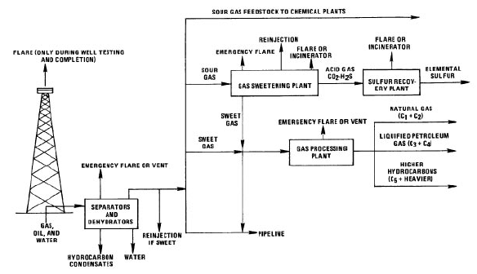

Figure 5.1 Venting and flaring outlet at a gas and oil production plant.

Venting emission points at major oil and natural gas processing facilities includes process vents at certain size glycol dehydration units and tanks with flashing emission potential.

In some cases, venting is the best option for disposal of the associated gas. For example, in some cases, a high concentration of inert gas is present in the associated gas. Without a sufficiently high hydrocarbon content, the gas will not burn and flaring is not a viable option. Sometimes the source of inert gas may come from the process systems. The purging of process systems with inert gas may, in itself; justify venting as the safest means of disposal.

Venting takes place during routine maintenance that includes regular and periodic activities performed in the operation of the facility. These activities may be conducted frequently, such as launching and receiving scrapers (pigs) in a pipeline, or infrequently, such as evacuation of pipes (blowdown) for periodic testing or repair. In each case, the required procedures release gas from the affected equipment. Releases also occur during maintenance of wells (well workovers) and during replacement or maintenance of fittings.

Venting is practiced during system upsets and accidents. The most common upset is a sudden pressure surge resulting from the failure of a pressure regulator. The potential for unplanned pressure surges is considered during facility design, and facilities are provided with pressure relief systems to protect the equipment from damage due to the increased pressure. Release systems vary in design. In some cases, gases released through relief valves may be collected and transported to a flare for combustion or re-compressed and reinjected into the system. In these cases, methane emissions associated with pressure relief events will be small. In older facilities, relief systems may vent gases directly into the atmosphere or send gases to flare systems where complete combustion may not be achieved.

The frequency of system upsets varies with the facility design and the operating practices. In particular, facilities operating well below capacity are less likely to experience system upsets and related emissions. Emissions associated with accidents are also included in the category of upsets.

Sources of Vented Emissions

High-Bleed Pneumatic Device Vented Emissions
The pressurized gas that is released from the crude in the separator is often used in a facility’s process control systems. The gas is used to transmit signals between sensing and control devices and to drive automatic control valves for controlling liquid levels, flow rates and pressures. Pneumatic control valves are designed to bleed gas to the atmosphere as they cycle up and down to modulate the system being controlled. Venting from high-bleed pneumatic devices is the second largest source of methane emissions from the oil industry. It is calculated from the emission factor of 350 standard cubic feet per day (scfd) per device.

Low-Bleed Pneumatic Device Vented Emissions
Venting from low-bleed rate pneumatic controllers is estimated to be only 10 percent of the activity factor for high-bleed devices, or 35 scfd per device.

Chemical Injection Pump Vented Emissions
Chemical injection pumps are used to inject various chemicals into crude oil at the well site. The injected chemicals are used to break oil-water emulsions, inhibit corrosion, dewax paraffins, kill bacteria and control other processing problems. As in the case of pneumatic devices, the pressurized natural gas that is frequently available at oil production sites may be used to drive chemical injection pumps. The estimated average emission rate for each pump is 91 Mcf/y. The activity factor is computed by using the estimate that 25 percent of pumps are driven by gas. The remainder are driven mechanically or by electric motors or compressed air.

Stripper Well Vented Emissions
Stripper wells are those that produce fewer than ten barrels of oil a day. The average production rate for stripper wells is 2.1 barrels per day; approximately one-third of the stripper wells produce an average of one barrel of crude per day. Methane is emitted from the casing head valves on an estimated 80 percent of stripper wells that are left open to maximize oil flow. This is because gas pressure buildup in the well casing can restrict the already slow drainage of oil from the reservoir into the well. Based on an estimated gas/oil ratio of five scf of gas per barrel of crude, the annual total hydrocarbon gas emission is 3,832 scf per stripper well. Using the API speciation fraction of 0.612 for light oil methane content, the annual methane emission factor is 2,345 scf per stripper well.

Storage Tank Vented Emissions
Storage tank vented emissions, which come from tank farms associated with crude terminals and pipelines, are estimated to be 20.6 scf per 1,000 barrels of crude.

Pumping Station Vented Emissions
Very small amounts of methane are emitted from crude that is exposed to the atmosphere when pipeline pumping stations are dismantled for maintenance. It has been estimated that only 36.8 scf is released per station each year.

Pipeline Pigging Vented Emissions
Pigs, or scrapers, are cylindrical devices, equipped with blades and brushes, that are used to clean build-ups of water, rust, wax, sludge or other materials from pipelines. Pipeline pigging operations are a potential source of methane emissions when pig stations are opened to inject and recover pigs. CAPP estimates that the emission factor for pig stations is 39 scf per day per station.

Other Vented Emissions
There are several smaller sources of vented emissions in the oil and gas production sectors such as pressure vessel and compressor blowdowns, compressor starting and oil well completions and workovers. Total vented emissions from these sources are insignificant.

Upset Vented Emissions

Upset emissions are unintentional releases that occur when a process goes out of control.
Examples of process upset emissions are releases from emergency pressure relief valves and oil well blowouts during oil well drilling operations.

Process upset venting is the least significant source of methane emissions in the oil production sector. Upsets include offshore platform emergency shutdowns, pressure relief valve (PRV) releases and well blowouts.

Pressure relief valves (PRVs) are usually installed on pressurized vessels to prevent catastrophic failure of the vessel from an uncontrolled pressure rise. In production facilities, the usual pressure vessels are separators and heater treaters. The emission factor of 34 scf/y per PRV has been used by the oil industry.

Oil well blowout emissions occur when a drill bit enters a reservoir that is pressurized above the pressure level expected for the well depth. Normally anticipated pressures are approximately equal to the hydrostatic head of a column of salt water to the depth of the well. Higher pressures can be caused by water drives that have sources at higher altitudes than the wellhead or by geopressuring from soil overburden buildup on unconsolidated reservoir sands as can occur beneath river deltas. The emission factors are very uncertain though gas and oil industry.

The owner or operator of any gas/oil production or processing facility during malfunction, startup, shutdown or scheduled maintenance could be excused of temporary noncompliance with applicable Ambient Air Quality Standards (AAQS) providing that:

- The inconsistency with any air quality control regulation results from a malfunction or damage to process or air pollution control equipment, result from unavoidable conditions during startup or shutdown, or result from scheduled maintenance.

- Repairs to the equipment causing the excess emissions are made with maximum reasonable effort, including the use of off-shift and overtime labour as needed.

- The emission of air contaminants is minimized as much as practicable during the period of excess emissions.

- Excess emissions do not occur with such frequency that careless, marginal or unsafe operation is indicated.

- The air contaminant is not of a nature or quantity which would endanger public health or safety.

The owner or operator of the facility experiencing the malfunction, startup or shutdown should notify the regulatory authority verbally as soon as possible, but no later than 24 hours after the start of the next regular business day, and should submit written notification within 10 days following the initial occurrence of the excess emissions.

In the case of scheduled maintenance, the owner or operator of the facility should notify the regulatory authority verbally no later than 24 hours prior to the initial occurrence of the excess emissions and should submit written notification within 10 days after the start of the next regular business day. The notification should include:
  - the name of the firm experiencing the malfunction, startup, shutdown or scheduled maintenance and the name and title of the person reporting;
  - the location of the facility at which the malfunction, startup, shutdown or scheduled maintenance occurred or is occurring;
  - identification of the equipment involved and the emission point or points (including bypass) from which the excess emissions occurred or are occurring;
  - the approximate, or if available, the specific time period that the facility was or will be experiencing excess emissions;
  - identification of the air contaminant or contaminants and an estimate of the magnitude of excess emissions expressed in the units of the applicable emission limit for the air contaminant or contaminants of excess emission;
  - the cause and nature of the malfunction condition or shutdown and the reasons why excess vent emissions occurred or are occurring; and
  - the efforts taken to minimize emissions and efforts to repair or otherwise bring the facility into compliance with the applicable emission limits or other requirement.

If the period of excess emissions extends beyond the submittal of the written notification, the owner or operator of the facility should also notify the regulatory authority in writing of the exact time period when the excess emissions no longer occurred.

Estimation of Vented Emissions from Gas and Oil Systems

Emission estimate from venting points shall be accomplished by direct measurement (see Section 8) or by any of the simplified methods based on activity data, the emission factors and computer programs when it is not practical to metre vented or flared gas.

Estimating methods must account for all gas flared or vented (expressed to the nearest 100 m³/month) from the facility, including routine, emergency and maintenance operations and depressuring of vessels, compressors and pipelines.

Estimates must be based on calculations that account for the volume, gas composition, temperature and initial and final pressures of systems vented or depressurized to flare.

Procedures for estimating vented or flared volumes must be developed by a qualified technical person, documented and available for inspection by the regulatory authority.

A formal system for logging and reporting flaring or venting incidents should be in place and include procedures for reporting the information to the regulatory authority.

The owner or operator will be expected to produce documented vents estimating procedures, reporting procedures and logs for review by the regulatory authority as required. The regulatory authority may require installation of metres in instances where there are repeated failures to demonstrate adequate flare or vent gas estimating and reporting systems.

Venting from oil storage tanks is the largest source of methane emissions in the oil industry. These tanks hold crude oil that has flown through a separator (a pressure vessel used to separate well fluids into oil, gas, and water). When the crude enters the storage tanks, which are at atmospheric pressure, some of the dissolved gases and lighter liquid hydrocarbons flash off (vapourize). Most of these tanks are vented to the atmosphere, allowing methane and other gases to escape.

Estimation of methane emission based on activity data requires calculation of activity level expressed in million Btu (MMBtu) from oil production data in barrels and gas production data in thousand cubic feet (Mcf) applying conversion factors given in Table 5.1.

Table 5.1 Conversion Factors to Million BTU (MMBtu)

Product Type | Unit of Production | Multiply by
Crude Oil  Natural Gas | Barrels  Thousand Cubic Feet | 5.800  1.000

Median estimate of methane emissions in pounds is calculated from the formula:

Lbs CH₄ = Activity Level (MMBtu) x Emission Factor (median, lb CH₄/MMBtu)

Emission factors are given in Table 5.2.

Table 5.2 Methane Emission Factors for Oil and Gas Activities

Activity | Emission Factor (lb CH₄/MMBtu)
Activity | Low | High | Median
Gas Production  Oil Production  Oil & Gas Venting | 0.1069  0.0007  0.0035 | 0.1952  0.0116  0.0163 | 0.1510  0.0062  0.0099

Another method of methane emissions estimation is based on the emission factor of 18 scf of CH₄ per barrel of oil.

The use of a displacement equation is the preferred method for estimating VOC, HAP, and CH₄ emissions from emergency and process vents, gas actuated pumps, pressure/level controllers, blowdown, well blowouts and well testing. The displacement equation can also be used to estimate H₂S and CO₂ emissions from gas sweetening units venting to the atmosphere and for H₂S emissions from mud degassing operations. The following equations can be applied to estimate emissions when no chemical conversion occurs:

E_{x} = Q ∙ MW ∙ X_{x} ∙ 1/C
where:
E_{x} = Emissions of pollutant x
Q = Volumetric flow rate/volume of gas processed
MW = Molecular weight of gas
X_{x} = Mass fraction of pollutant x in gas
C = Molar volume of ideal gas, 379 scf/lb-mole at 60ºF and 1 atmosphere

Speciated VOC emissions are calculated using the following equation:

E_{x} = E_{VOC} ∙ X_{x}
where:
E_{x} = emissions of pollutant x
E_{VOC} = total VOC, calculated using the E_{x} equation
X_{x} = mass fraction of species x in VOC

Vented emissions can be calculated using computer models. They are the preferred emission estimation technique for glycol dehydrators, storage tanks, flash losses from black oil systems and volatile organic compounds (VOC) and hazardous air pollutants (HAP) losses from amine-based gas sweetening units venting to the atmosphere. Depending on the purpose of the inventory, the owner or operator of a gas/oil facility should check with the regulatory authority to confirm the model is acceptable. Two most common computer models are as follows:

(a) VOC and HAP emissions from glycol dehydrators can be estimated using the GLYCalc model. GLYCalc provides users the option of applying thermodynamic equations or the Rich/Lean method to estimate emissions. The model requires process-specific data to produce an accurate emission estimate. As with any emission estimation model, the user should be cautious when collecting this data to make sure the correct data is collected at the right point in the process line. In addition, models including GLYCalc offer default values for some parameters if process-specific data is not available. While simplifying the data collection process, use of defaults that are not appropriate for a particular unit may result in invalid or inaccurate emission estimates. In all cases, therefore, the user is encouraged to collect and use process-specific data to obtain the most accurate emission estimate. More information about GLYCalc as available on the Internet at www.gri.org/pub/env-new/final/products/gly4.html.

(b) A Windows-based computer software program TANKS4 estimates VOC and HAP emissions from fixed- and floating-roof storage tanks. TANKS is based on the emission estimation procedures from EPA's Compilation of Air Pollutant Emission Factors (AP-42). The program includes on-line help for every screen. The program uses chemical, meteorological, roof fitting, and rim seal data to generate emissions estimates for several types of storage tanks, including:
- vertical and horizontal fixed roof tanks;
- internal and external floating roof tanks;
- domed external floating roof tanks; and
- underground tanks.

To use the program, the operator shall enter specific information about storage tank construction and the stored liquid. The program produces a report estimating VOC emissions. A batch mode of operation is available to generate a single report for multiple tanks. Current version 4.09 of the TANKS software is available at the Internet site www.epa.gov/ttn/chief/software/tanks/

Venting Control

To protect the atmosphere from vented air pollutant, the owner or operator of a gas or oil facility should consider a well-maintained vapour-recovery system consisting of:

- A vapour-gathering system capable of collecting the vapour and gases discharged.

- A vapour-disposal system capable of processing the vapour and gases so as to minimize emission of HAP to the atmosphere.

- Any other device that is at least as efficient to minimize the loss of vented vapour or gas containing HAP to the atmosphere.

- A floating roof, consisting of an external floating roof, internal floating cover or covered floating roof equipped with a closure seal or seals maintained in good repair to close the space between the roof or cover edge and tank wall, if the stationary tank or other container is equipped with a floating roof.

If continuous vent volumes are sufficient to support combustion, the gas should generally be burned in a flare to lower equivalent greenhouse gas CO₂ emissions, providing that releases are of 24 hours or less in duration.

Sour Well Venting

The classification of critical sour wells is based on two primary criteria, H₂S release rate potential and the wells' proximity to urban centres. A critical sour well includes:

- Any well located within 500 m of the corporate boundaries of an urban centre where the maximum potential H₂S release rate is from 0.01 m³/s to 0.1 m³/s.

- Any well located within 1.5 km of the corporate boundaries of an urban centre where the maximum potential H₂S release rate is from 0.1 m³/s to 0.3 m³/s.

- (c) Any well located within 5.0 km of the corporate boundaries of an urban centre where the maximum potential H₂S release rate is from 0.3 m³/s to 2.0 m³/s.

(d) Any well from which the maximum potential H₂S release rate is 2.0 m³/s or greater, or any other well which the regulatory authority classifies as a critical sour well having regard to the maximum potential H₂S release rate, the population density, the environment, the sensitivity of the area, where the well is located and the expected complexities during the completion or servicing operation.

In instances where expected productivity or concentration of H₂S was not realized, as a result of reservoir depletion or any other factors that resulted in a reduction in the maximum H₂S release rate at the well, the regulatory authority will consider applications to remove the sour well critical designation. Applications to reclassify the well to a non-critical designation should be based on the most recent and complete information available.

Glycol Dehydration Unit Process Venting

This section applies to each glycol dehydration unit with an actual annual average natural gas flowrate equal to or greater than 85,000 standard cubic metres per day and with actual average benzene glycol dehydration unit process vent emissions equal to or greater than 0.90 tonnes per year. The owner or operator should follow the voluntary approach agreed to by a multi-stakeholder task force whereby the oil and gas industry committed to reduce and report on benzene emissions from natural gas dehydrators by implementing Best Management Practices for the Control of Benzene Emissions from Glycol Dehydrators.

The owner or operator should connect the process vent to a control device or combination of control devices through a closed-vent system and the outlet benzene emissions from the control device(s) should be reduced to a level less than 0.90 tonnes per year.

As an alternative to the requirements of Section 5.7.2, the owner or operator may comply with one of the requirements:

- Control air emissions by connecting the process vent to a process natural gas line.
- The total HAP emissions to the atmosphere from the glycol dehydration unit process vent are reduced by 95.0 percent through process modifications, or a combination of process modifications and one or more control devices.
- Total benzene emissions to the atmosphere are reduced to a level less than 0.90 tonnes per year from the glycol dehydration unit process vent.

Venting Requirements and Recommendations

Where it is not practical to recover or flare gas, the regulatory authority may accept venting of small volumes of gas. Venting may be considered as an alternative for disposition of small gas volumes from compressor vents, instrument gas systems, pneumatic devices, dehydrators and storage tanks.

Gas should not be vented if it constitutes an unacceptable fire or explosion hazard on or off the facility lease.

Venting of gas containing H₂S to the atmosphere should not result in exceedance of applicable Ambient Air Quality Guidelines for H₂S or Occupational Exposure Levels for H₂S.

Stock tank vapours and other gas emissions from batteries receiving gas or having vapours containing more than 10 moles of H₂S per kilomole of gas should be burned.

Continuous venting of gas containing H₂S and other odorous compounds should not result in odours outside the lease boundary.

The true vapour pressure of hydrocarbon product stored in atmospheric storage tanks should not exceed a true vapour pressure of 83 kilopascals where such tanks are vented to the atmosphere.

An appropriate flame arrester or equivalent safety device should be used on all vent lines from oil storage tanks connected to flare stacks.If the owner or operator has reason to expect that the benzene content of vented gas exceeds 5 moles per kilomole, then site vent gas benzene emissions should be assessed and, if necessary, controlled so that total benzene emissions for the facility or lease site will not exceed:

- 3.0 tonnes per year for new facilities.
- 5.0 tonnes per year for facilities commissioned prior to the issuance of this Code.
- Any other well which the regulatory authority classifies as a critical sour well having regard to the maximum potential H₂S release rate, the population density, the environment, the sensitivity of the area where the well is located and the expected complexities during the completion or servicing operation.

- SULPHUR RECOVERY

Introduction

Hydrogen sulphide (H₂S) is a byproduct of processing natural gas and high-sulphur crude oils. The recovered hydrogen sulphide gas stream may be:
- vented;
- flared in waste gas flares or modern smokeless flares;
- incinerated; or
- utilized for the production of elemental sulphur or sulphuric acid.

If the recovered H₂S gas stream is not to be utilized as a feedstock for commercial applications, the gas is usually passed to a tail gas incinerator in which the H₂S is oxidized to SO₂ and is then passed to the atmosphere out a stack becoming an air contaminant.

To protect the atmospheric environment from excessive H₂S emissions, the Claus process is used to convert H₂S to elemental sulphur. The Claus process is the most common conversion method in which approximately 90 to 95 percent of sulphur released by gas and oil industry is recovered. At normal operating temperatures and pressures, the Claus reaction is thermodynamically limited to 97 to 98 percent recovery.

Components of gas processing facility which includes a sulphur plant are shown in Figure 6.1.
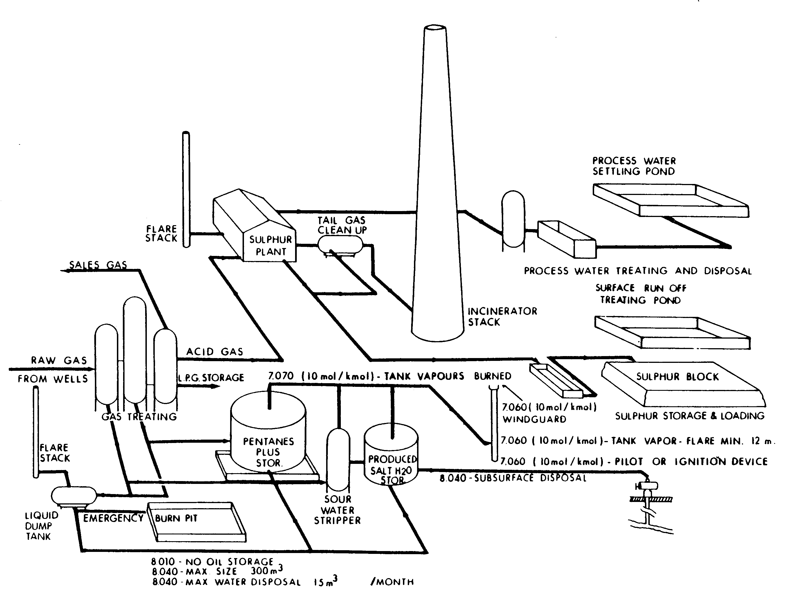
Figure 6.1 Schematic diagram of gas processing plant with sulphur recovery unit.

The Claus process consists of multistage catalytic oxidation of hydrogen sulphide to elemental sulphur. Figure 6.2 shows a typical Claus sulphur recovery unit.

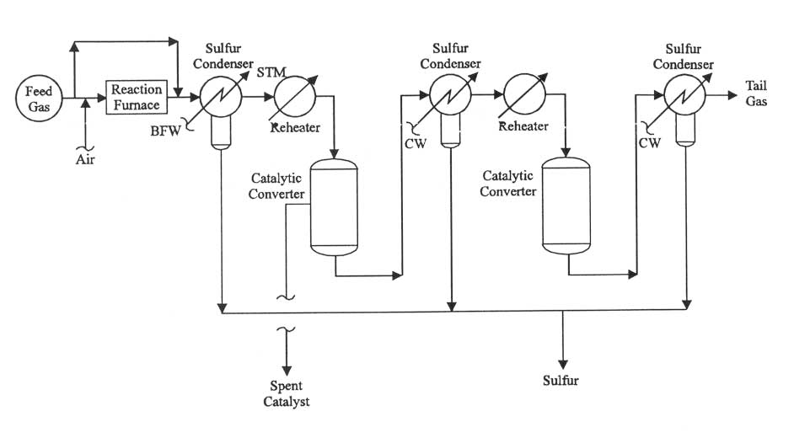
Figure 6.2 Typical Claus sulphur recovery unit.

CW = Cooling water. STM = Steam. BFW = Boiler feed water.

Emission sources associated with the Claus sulphur recovery process include the tail gas stream still containing 0.8 to 1.5 percent sulphur compounds. They are usually incinerated or may be passed through a liquid redox sulphur recovery unit, fugitive emissions from equipment leaks, and emissions from maintenance activities. In addition, residual H₂S, carbonyl sulphide (COS), and carbon disulphide (CS₂) may also be released to the atmosphere from the recovered molten sulphur.

In the liquid redox sulphur recovery process, vent gases from the oxidizer vessel are a potential source of emissions. Emissions associated with fixed bed adsorption or molecular sieve dehydration include fugitive emissions and emissions from maintenance activities which are considered minor sources of HAP emissions. Process heaters are often used to heat the regeneration stream, with the burner vents from these heaters being potential sources of HAP emissions. The redox sulphur recovery process is not addressed in this Air Quality Code of Practice because it contributes very little to overall emissions of oil and gas industry.

Emissions Estimate

Point Source Sampling
Direct point sampling is recommended for the accurate estimation of emissions to the atmosphere from a sulphur recovery plant following methodology described in Section 8.4 of this Code. Results of source sampling are used to calculate H₂S and SO₂ emissions from the sulphur recovery process with the following equations for each compound:

(a) SO₂ emission estimate (E_{SO2}), lb/h

E _{SO2} = Q · y_{SO2} · F_{S} · MW_{S} · 1/C · (MW_{SO2}/MW_{S}) · F_{SO2} · (1 – RE/100)

where: Q = gas process rate, scf/h
y_{SO2} = mole fraction of SO₂ in inlet gas stream
F_{s} = sulphur recovery factor (1 mole sulphur/mole SO₂)
MW_{S} = molecular weight of sulphur
C = molar volume of ideal gas, 379 scf/mole at 60ºF and 1 atm
MW_{SO2} = molecular weight of SO₂
F_{SO2} = SO₂ production factor (1 mole SO₂/ 3 moles S)
RE = sulphur recovery efficiency, %

(b) H₂S emission estimate (E _{H2S}), lb/h

E _{H2S} = Q · y_{H2S} · F_{S} · MW_{S} · 1/C · (MW_{H2S}/MW_{S}) · F_{H2S} · (1 – RE/100)

where: Q = gas process rate, scf/h
y_{H2S} = mole fraction of H₂S in inlet gas stream
F_{s} = sulphur recovery factor (1 mole sulphur/mole H₂S)
MW_{S} = molecular weight of sulphur
C = molar volume of ideal gas, 379 scf/mole at 60ºF and 1 atm
MW_{H2S} = molecular weight of H₂S
F_{H2S} = H₂S production factor (2 mole H₂S/ 3 moles S)
RE = sulphur recovery efficiency, %

Emission Factors
The general equation for emission estimation using emission factors is:

E = A ∙ EF ∙ (1-ER/100)
where: E = emissions,
A = activity rate,
EF = emission factor, and
ER = overall emission reduction efficiency, %.

Table 6.1 shows emission factors and recovery efficiencies for modified Claus sulphur recovery plants (EPA, AP-42). Factors are expressed in units of kilograms per megagram (kg/Mg) and pounds per ton (lb/ton).
Table 6.1 Emission Factors for Claus Sulphur Recovery Plant

Number of  Catalytic Stages | Average %  Sulphur Recovery ª | SO₂ Emissions
Number of  Catalytic Stages | Average %  Sulphur Recovery ª | kg/Mg of Sulphur Produced | lb/ton of Sulphur Produced
1, Uncontrolled  3, Uncontrolled  4, Uncontrolled  2, Controlled ^{f}  3, Controlled ^{g} | 93.5 ^{b}  95.5 ^{d}  96.5 ^{e}  98.6  96.8 | 139 ^{b, c}  94 ^{c, d}  73 ^{c, e}  29  65 | 278 ^{b, c}  188 ^{c, d}  145 ^{c, e}  57  129

ª Efficiencies are for feed gas streams with high H₂S concentrations. Gases with lower H₂S concentrations would have lower efficiencies. For example, a 2- or 3-stage plant could have a recovery efficiency of 95% for a 90% H₂S stream, 93% for 50% H₂S, and 90% for 15% H₂S.
^{b} Based on net weight of pure sulphur produced. The emission factors were determined using the average of the percentage recovery of sulphur. Sulphur dioxide emissions are calculated from percentage sulphur recovery by one of the following equations:
SO₂ emissions (kg/Mg) = 2000 ∙ (100% recovery) / ( % recovery)
SO2 emissions (lb/ton) = 4000 ∙ (100%recovery) / ( % recovery)
^{c} Typical sulphur recovery ranges from 92 to 95%.
^{d} Typical sulphur recovery ranges from 95 to 96%.
^{e} Typical sulphur recovery ranges from 96 to 97%.
^{f} Test data indicated sulphur recovery ranges from 98.3 to 98.8%.
^{g} Test data indicated sulphur recovery ranges from 95 to 99.8%.recovery efficiencies. The efficiency depends upon several factors, including the number of catalytic stages, the concentrations of H2S and contaminants in the feedstream, stoichiometric balance of gaseous components of the inlet, operating temperature, and catalyst maintenance.

The estimation method will be specified by the regulatory authority in the operation permit, emissions verification, public complaints, or for other reasons.

Emissions Reduction

Emissions reduction is required in order to meet sulphur emission criteria detailed in Section 6.4 and to assure that ambient air quality guidelines applicable to NWT are met (see Table 9.1).

Emissions reduction from the Claus process may be accomplished by:

- Extending the Claus reaction into a lower temperature liquid phase by adopting any of five processes currently available including the BSR/selectox, Sulfreen, Cold Bed Absorption, Maxisulf and IFP-1 processes. These processes take advantage of the enhanced Claus conversion at cooler temperatures in the catalytic stages. They give higher overall sulphur recoveries of 98 to 99 percent when following downstream of a typical 2- or 3-stage Claus sulphur recovery unit.

- Adding a scrubbing process to the tail end to the end of the Claus plant. Currently available are oxidation tailgas scrubbers and reduction tailgas scrubbers. The first scrubbing process is used to scrub SO₂ from incinerated tailgas and recycle the concentrated SO₂ stream back to the Claus process for conversion to elemental sulphur.

- There are at least 3 oxidation scrubbing processes: the Wellman-Lord, Stauffer Aquaclaus, and IFP-2. The Wellman-Lord process has been applied more often than the other two. This process uses a wet generative process to reduce stack gas sulphur dioxide concentration to less than 250 ppmv and can achieve approximately 99.9 percent sulphur recovery

- Incinerating the hydrogen sulphide gases to form sulphur dioxide at a temperature of 650°C (1,200°F) or higher to assure that all of the H₂S is combusted. Proper air-to-fuel ratios are needed to eliminate pluming from the incinerator stack. The stack should be equipped with analyzers to monitor the SO₂ level. Dispersion modelling should be used to calculate the stack height required to comply with ambient air quality standards for SO₂ (see Section 9).

Compliance

Sulphur recovery is required for all gas and oil plants where the plant inlet sulphur rate is:

- 2 tonnes per day (t/d) of sulphur or more; or

- less than 2 tonnes per day of sulphur if ambient air quality guidelines for sulphur compounds are not met.

The sulphur recovery criteria will also apply to any oil and gas production facilities which use sour gas as a fuel and have air emissions from the combusted fuel equal to or greater than 2 t/d of sulphur.

Sulphur recovery criteria and recommended Claus technologies for gas plants at various inlet sulphur rates should be as defined in Table 6.2.

Table 6.2 Sulphur Recovery Criteria for Gas Plants

Plant Inlet Sulphur Rate (t/d) | Minimum Sulphur Recovery ª | Technology ^{b}
< 2  2 - < 10  10 - < 50  50 - < 2000  2000+ | 0  89.7  95.9  98.2 – 98.5 ^{c}  99.5 | N/A  2 stage Claus unit  3 stage Claus unit  2-3 stage sub-dew point Claus unit  2-3 stage Claus plus selective absorption tail gas unit

ª The minimum sulphur recovery criteria will be decreased in cases of poor acid gas quality (i.e. where the mole percentage of H₂S in the acid gas feed stream from the amine unit or equivalent is less than 40%). The minimum sulphur recovery will be decreased by 0.068% for every 1.0 mole % H₂S that the acid gas feed stream has less than 40 mole % H₂S. The regulatory authority may on occasion require operations which qualify for this relaxation to conduct sulphur recovery technology evaluations to explore if reducing or removing the relaxation is reasonable.
^{b} Technologies are cited as examples of technology which typically could meet these requirements and are not intended as requirements or recommendations (see Section 6.3).
^{c} For plant sizes 50 - <2000 t/d, % sulphur recovery required = 98.2 + 0.187[log10(plant size/50)]

The percentage of sulphur recovery shall be calculated and reported each calendar month on a three month rolling average basis. The 3 month rolling average must be greater than or equal to the sulphur recovery criteria. The three month rolling average will be calculated from the total weight of sulphur produced at the plant, the total weight of sulphur emitted from the stacks as recorded by the required continuous emission monitors, and the total of any other emissions of sulphur from the sour gas processing (e.g. flare) in the last three months as follows:

Ravg = [Wp /( Wp + Ws + Wd)] ∙ 100

where Ravg = 3 month rolling average sulphur recovery (%)
Wp = total weight of sulphur produced in the previous 3 months (tonnes)
Ws = total weight of sulphur emitted through the incinerator stack in the previous 3 months (tonnes)
Wd = total weight of sulphur emitted through the plant flare system in the previous 3 months (tonnes)

Sulphur emissions from sulphur recovery plants of equal or greater than 20 tonnes per day capacity should be limited to 0.025 percent by volume (250 parts per million by volume [ppmv]). This limitation is effective at 0 percent oxygen on a dry basis if emissions are controlled by an oxidation control system or a reduction control system followed by incineration. This is comparable to the 99.8 to 99.9 percent control level for reduced sulphur.

Sulphur emissions from sulphur recovery plants of less than 20 tonnes per day capacity should not exceed emissions to the atmosphere in excess of 10 gram of sulphur for every 100 gram of sulphur introduced into the plant.

The owner or operator of a natural gas processing plant should not permit, cause or allow sulphur compounds to be emitted to the atmosphere unless the sulphur compound emission is from a stack of a sufficient physical height to prevent concentrations of sulphur compounds near ground level equal to or exceeding relevant ambient air quality objectives. The necessary physical stack height should be determined by appropriate dispersion modelling method following Section 9.

The owner or operator of an existing natural gas processing plant should file with the regulatory authority the following:

- The height of all stacks from which sulphur is emitted.

- The quantity of the sulphur emitted from each stack.

- The exit gas temperature for each stack.

- The total mass flow rate of the stack effluent gases (for flares, the total effluent mass flow rate shall consist of the stack effluent mass flow rate plus that amount of air required for complete combustion).

- Any other information the regulatory authority deems necessary to determine whether or not the physical height of any stack from which sulphur is emitted complies with the requirements of this Section.

This Section should not apply to a sulphur recovery plant for which a sulphur emission limitation is established by any other air quality control regulation.

The regulatory authority should revoke any gas/oil processing plant's approval to operate if the processing plant exceeds by more than five hundred kilograms for any two consecutive quarterly periods the amount of sulphur to be released in plant processes as set forth in the sulphur release schedule contained in the approval. The regulatory authority should notify the owner or operator of the processing plant by certified mail of the revocation of the plant's approval.

Reporting

To aid the regulatory authority in determining compliance with this section, the owner or operator of a sulphur recovery plant to which this section applies should submit quarterly reports for the annual period, each report to be received by the authority within 45 days of the end of the quarterly period. The quarterly report should contain the following:

- The sulphur content of feedstock entering the sulphur recovery plant, determined no less frequently than three times per week and no more frequently than once every twenty-four hours.

- The sulphur content of all fuel burned in the plant and the amount of each type of fuel burned determined no less frequently than quarterly.

- The concentration of sulphur dioxide and hydrogen sulphide in the inlet and outlet gas stream or streams of the sulphur recovery plant determined no less frequently than monthly.

- The weight of the recovered sulphur, determined no less frequently than weekly.

When the sulphur recovery plant has at some time during the operational quarterly period experiences excess emissions during malfunction, startup, shutdown, or scheduled maintenance, and complied with the notification requirements of a relevant regulation, quantities and time periods involved in the quarterly reports may be modified to exclude the time periods and the quantities involved during those time periods if the quantities are determined separately for those time periods and submitted in the quarterly report.

The owner or operator should provide one month advance notice to the regulatory authority about any scheduled shutdown, maintenance, startup, etc. estimating amount of potential releases of sulphur-containing gases.

A leak, break, or malfunction resulting in a release of SO₂ and H₂S to the atmosphere, shall immediately be reported to the NWT 24-Hour Spill Report Line and the regulatory authority.

If it appears necessary, the regulatory authority may require reports on a more frequent basis, but no more frequently than monthly.

The regulatory authority may, upon the request of the owner or operator of a gas or oil processing plant, alter the sampling periods specified in this section.

The owner or operator of a sulphur recovery facility that manufacture, process or otherwise use one or more of the National Pollutant Release Inventory (NPRI)-listed substances under prescribed conditions are required to report to the NPRI under the authority of the Canadian Environmental Protection Act, 1999 (CEPA, 1999).

NOISE

Introduction

With the growth of oil and natural gas operations in Northwest Territories, there are increasing sources of noise. Some of the most common are associated with compressor stations, processing plants, well batteries, well drilling and servicing, and transportation vehicles and construction equipment.

It is not possible to eliminate all noise due to energy- related developments. However, if operators build proper sound-control features into their facilities, sound levels can be kept to acceptable minimums. The Government of Northwest Territories (GNWT) recognizes that protection from excessive upstream oil and gas industry-related noise is important to the quality of life in NWT.

Although the regulatory authority requirements cannot guarantee that residents will not hear sounds from facilities or operations, the basic principles of noise control are clear:
- sound level increases should be kept to acceptable minimums;
- overall quality of life for the neighbours of energy facilities should not be impaired;
- wildlife should not be adversely affected by excessive noise; and
- indoor sound levels should not change significantly, particularly as they affect normal sleep patterns.

The regulatory authority requires owners or operators to conduct noise impact assessments for all new facilities, as well as for modifications to existing facilities. In an assessment, an operator should predict the amount of noise a proposed facility or modification will make, and if it exceeds the Permissible Sound Level, identify ways to reduce that noise. This helps to convince the regulatory authority that the effects of noise are anticipated and that noise abatement is part of the facility design.

The regulatory authority endorses noise control directives of Alberta Energy and Utilities Board (EUB) which have been in effect since 1973. The latest updates, Interim Directive (ID) 99-8: Noise Control Directive and its companion, Guide 38: Noise Control Directive User Guide, both issued in November 1999, reflect the most current knowledge about noise control applicable to upstream oil and gas industry. The Guide 38 is enclosed as Appendix D.

Noise Regulations

Usually permissible noise levels are defined by bylaws for an administrative area where oil/gas facility is located. Typical permissible sound levels (PSL) existing in many municipalities are given in Table 7.1.
Table 7.1 Typical Bylaw Permissible Sound Levels

Area Category | dBA, Leq
Area Category | Day Time | Night Time
Residential  Commercial  Industrial  Silence Zone / Parks | 55  65  75  50 | 45  55  70  40

In the absence of noise bylaw, the EUB Guide 38 Noise Control Directive should be used. The Guide specifies the following:

(a) New facilities planned for remote area should be designed to meet a target sound level of 40 dBA Leq at a distance of 1.5 km from the noise source, although this is not a mandatory requirement and as a target, this does not establish compliance should infringement occur.

(b) Permissible sound level may be derived from a Basic Sound Level (the BSL) value that includes a 5 dBA Leq allowance for industrial presence plus adjustments intended to more accurately reflect specific aspects of the facility and the environment. The minimum PSL for rural NWT is probably no less than 40 dBA Leq during nighttime. However, there may be pristine natural areas where an ambient adjustment may result in a lower PSL, while more developed areas may result in a higher PSL. The PSL is calculated as follows:

Permissible Sound Level | = | Basic Sound Level | + | Daytime Adjustment | + | Class A Adjustment | + | Class B Adjustment
The daytime period is 07:00 to 22:00, and the daytime adjustment is +10 dBA. Class A adjustment depends on the nature of the activity and/or the actual ambient sound level (ASL) in an area. Class B adjustment is influenced by people’s responses to temporary activities. Details of adjustments calculation are given in Appendix D.

- The Permissible Sound Levels do not apply in emergency situations. Planned maintenance or operational events may be considered temporary activities and thus qualify for a Class B adjustment. Prior to such events, operators should inform nearby residents of the potential for increased sound levels and should attempt to schedule the events during daytime hours to reduce the noise impact on neighbours.

- A territorial, or municipal authority may delimit and publish control zones of different noises according to the noise conditions in its territory of jurisdiction, and should make periodic review for re-delimitation and re-publication of such zones.

In case that the owner or operator intends to install any industrial facility, he should complete an application form for an installation permit to local regulatory authorities containing following information:
- name, type, specification and quantity of facilities;
- facilities installation location plan which should include, within a hundred metres from such facilities, the related locations and distance of the subordinate road network and the nearby residential areas;
- the designed sound level and operation condition of facilities; and
- other related documents.

The owner or operator of the facility that has obtained installation permit should submit the following documents within six months from the date of the completion of installation to apply for an operation permit from local juridical authorities; and those who have installed such facility should submit the following documents to apply for an operation permit from local juridical authorities six months within the proclamation:
- photocopy of the installation permit for new installation;
- photographs and illustrations of the completed installation of the facility;
- photographs and illustrations of noise control measures;
- information about the operation time and condition of the facility;
- noise inspection report; and
- other related documents.

In case that such applications should be incomplete or should not satisfy the requirements, local juridical authorities should inform the applicants to make a remedy at a certain period within fifteen days from the date of acceptance. Such a period for remedy should not exceed ninety days. In case that an applicant should fail to make a remedy within the specified period, such an application should be overruled.

If there is any place in which tranquility is deemed specially necessary by the competent authority concerned, an area within 50 metres surrounding the periphery of such place should be delimited as a special control area in concerned zone and the highest permissible sound volume in such an area should be 5 dB lower than that permitted in the zone. The sound volume at the adjoining border of two or more noise control zones should not exceed the noise control criteria set for any of the adjoining zones.

In the case when a compliance cannot be achieved, the owner or operator may apply to the regulatory authority for a temporary permit to operate. The application should provide the following information:
- the name, address and telephone number of the applicant;
- the address of the site;
- the facility permit number (if applicable);
- a description of the source(s) of noise or sound levels;
- the period of time that the temporary permit is desired;
- the applicant’s reason(s) why the temporary permit should be given; and
- a statement of the measures that will be taken to minimize the noise or sound levels.

Noise Monitoring

The following provide guidance for the measurement of sound levels from oil and gas operations:

- The comprehensive sound level (CSL) should be measured and compared to the PSL. Modelling of the industrial noise source component can be used as a diagnostic tool to assist in the timely resolution of noise concerns but not to demonstrate compliance.

- The CSL for the facility should not exceed the PSL. The (CSL) is determined by conducting a continuous sound-monitoring survey, which should encompass a representative portion of the times of day or night on typical days when the noise causing the complaints occurs over a minimum 6-hour to maximum 24-hour period. The maximum survey time may exceed 24 hours where warranted. These exceptional circumstances should be discussed with the regulatory authority before proceeding. If the required survey period straddles the daytime/nighttime periods, then a minimum of three survey hours should be conducted within each of the daytime and nighttime periods. The measurements are to be conducted 15 m from the complainant’s dwelling or place of activity (e.g. trapline) in the direction of the noise source. The 15 m requirement may be altered if it is physically impossible or acoustically illogical.

- If there are no occupied building units impacted, sound levels shall be measured at a distance of 8 metres or more from the property line radiating the noise.

- If a complainant has highlighted specific weather conditions, plant operating conditions, or seasons, the monitoring should take place under these representative conditions. Representative conditions do not constitute absolute worst-case conditions or the exact conditions the complainant has highlighted if those conditions are not easily duplicated. In order to expedite complaint resolution, sound measurements should be conducted at the earliest opportunity when sound propagation towards the impacted dwelling is likely and representative conditions might exist. An extended duration survey (greater than 24 hours) may be considered to ensure representative conditions have been met if they are frequent but difficult to predict.

- Short-term measurement shall be made at the time when the noise generated is most representative or at the time designated by the applicant concerned.

- Sound level metres shall be equipped with wind screens, and readings taken when the wind velocity at the time and place of measurement is not more than 8 km/h.

- Sound level measurements shall be taken 1.2 metres above ground level and determined by averaging measurements made over fifteen-minute sample duration.

- In all sound level measurements, the existing ambient noise level from all other sources in the encompassing environment at the time and place of such sound level measurement should be considered to determine the contribution to the sound level by the oil and gas operation(s).

Location of monitoring points should adhere to the following recommendations:

- An environmental noise monitoring point should be more than 30 metres away from the edge of a road with a width of more than 8 metres, and more than 15 metres away from the edge of a road with a width of more than 6 meters but less than 8 meters.

- A traffic noise monitoring point should be on the road side; and if there are buildings on road side, should be located more than 1 metre away from the external line of the wall of the buildings.

- Monitoring transducers should be placed at the height of 1.2 to 1.5 metres from the ground surface.

- Each monitoring point should conduct more than twice 24-hour consecutive monitoring in each quarter.

- The location of the monitoring points as designated under the preceding section should not be changed arbitrarily, and data obtained from monitoring should be periodically submitted to the appropriate superior competent authority.

The results of a noise monitoring test should be clearly reported and forwarded to the relevant authority (if requested), or kept on file for reference. It is recommended that they also be made readily accessible to the community.

The following items are to be included in a noise monitoring report:
- the type of monitoring test conducted (that is, the development stage or receiver complaints);
- the development noise limits on the consent/license
- descriptions of the nearest affected receivers or, in the case of receiver complaints, description of the complainant and complaint;
- the monitoring location—this should be at the most affected point at or within the receiver’s boundary or, if that is more than 30 m from the receiver’s premises, at the most affected point within 30 m of the premises;
- the noise instrumentation used;
- the weather instrumentation used;
- the weather conditions during noise monitoring;
- the time(s) and duration(s) of monitoring, including dates. In the case of receiver complaints, these should coincide with the time of the offence. In the case of development-stage monitoring, these should cover the full cycle of activity;
- the results of noise monitoring at each monitoring location, including a comparison with the development limits;
- a statement outlining the development’s compliance or non-compliance with the limit;
- where noise exceedances are found (that is, the monitored noise level is higher than the limit), the reasons for non-compliance should be stated and strategies for management identified and stated; and
- where the noise exceedance is due to excessive noise levels from the development, the strategies to be used to manage the noise exceedance should be identified and stated.

Industrial Noise Mitigation

Typical noise sources on upstream oil and gas industrial sites include:
- engines;
- exhausts;
- fans;
- transport of materials, such as on conveyors and trucks;
- pumps and compressors;
- whistles and alarms;
- material dumping and scraping;
- electrical transformers and switching equipment; and
- transportation and service vehicles, especially diesel type.

The choice of noise control measures depends on both the degree of mitigation required and the undesirable characteristics of the noise source that need to be controlled. The actual measures chosen will also depend on site factors, such as the ability of the site to accommodate particular engineering measures relative to other measures and their site costs.

The owner or operator of oil/gas facility should select between three main mitigation strategies for noise control:

(a) Controlling noise at the source following Best Management Practice (BMP) and Best Available Technology Economically Achievable (BAT).

(b) Controlling the transmission of noise. There are two approaches: the use of barriers and land-use controls—which attenuate noise by increasing the distance between source and receiver.

(c) Controlling noise at the receiver.

Application of BMP includes the following types of practice:
- scheduling the use of noisy equipment at the least-sensitive time of day;
- placing noisy equipment behind structures that act as barriers, or at the greatest distance from the noise-sensitive area;
- orienting the equipment so that noise emissions are directed away from any sensitive areas, to achieve the maximum attenuation of noise;
- where there are several noisy pieces of equipment, scheduling operations so they are used separately rather than concurrently;
- keeping equipment well maintained;
- employing quiet practices when operating equipment; and
- offering staff education programs on the effects of noise and quiet work practices.

Application of BAT involves incorporation of the most advanced and affordable technology to minimize noise output from equipment, plant and machinery. Examples of uses of BAT are:
- adjusting reversing alarms on heavy equipment to make them ‘smarter’, by limiting acoustic range to the immediate danger area;
- using equipment with efficient muffler design;
- using quieter engines, such as electric instead of internal combustion or gas turbines;
- using efficient enclosures for noise sources; and
- active noise control.

Barriers controls noise in transmission. They are more effective if situated near the source or the receiver. Their effectiveness is also determined by their height, the materials used (absorptive or reflective), and their density. Barriers can take a number of forms—including free-standing walls along the facility generating noise. They are employed when source and receiver control is either impractical or too costly.

Exhaust from all engines, motors, coolers and other mechanized equipment should be vented in a direction away from all occupied buildings to the extent practicable.

In high-density areas all facilities within 120 metres of occupied buildings with engines or motors, which are not electrically operated, should be equipped with quiet design mufflers or equivalent. All mufflers should be properly installed and maintained in proper working order.

Road, railway, aviation, and other transportation noises should be prevented and controlled through appropriate measures taken by competent authorities in conjunction with appropriate government agencies.

Selecting an appropriate strategy for a proposed development or alterations to an existing development with reference to noise management involves the following steps, summarized in Figure 7.1:

  - Determining the noise reduction required to achieve the project-specific noise levels.

  - Identifying the specific characteristics of the industry and the site that would indicate a preference for specified measures.

  - Examining the mitigation strategy chosen by upstream oil and gas industry on similar sites with similar requirements for noise reduction; and considering that strategy’s appropriateness for the subject development.

  - Considering the range of noise-control measures available.

  - Considering community preferences for particular strategies. This is especially important when the community has particular sensitivities to noise.

The preference ranking (from most preferred to least preferred) for particular strategies is:

- Land-use controls—a long-term strategy preferable to other measures when such strategic decisions are possible in planning land use, as it separates noise-producing industries from sensitive areas and avoids more expensive short-term measures.

- Control at the source—BMP and BAT— used in conjunction, these strategies are the best after land-use planning, as they serve to reduce the noise output of the source so that the surrounding environment is protected against noise.

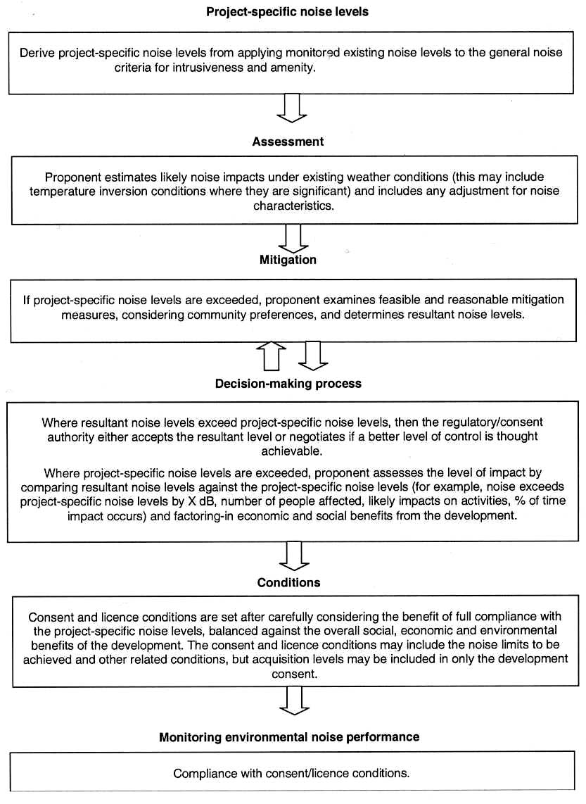

Figure 7.1 Overview of sound policy framework.
- Control in transmission—the next best strategy to controlling noise at the source—it serves to reduce the noise level at the receiver but not necessarily the environment surrounding the source.

- Receiver controls—the least-preferred option, as it protects only the internal environment of the receiver and not the external noise environment.

Proponent should envision the cost-effectiveness of strategies in determining how much noise reduction is affordable. A choice of a particular strategy is likely to have unique features due to the economics of the industry and site specific technical considerations. The steps described in the preceding Section and the range of noise control measures can be used as a guide in assessing the strength of the proponent’s mitigation proposals.

Where a proposed mitigation strategy will not achieve the desired noise reduction and leaves a remaining noise impact, the problem needs to be solved by negotiation.

MEASUREMENT AND REPORTING

Introduction

Under the Environmental Protection Act, the GNWT may require the installation of such monitoring devices as are necessary to measure the concentrations of various air contaminants. Any changes to emission quality or quantity relating to the facilities operation should be approved by the regulatory authority.

Nationally and internationally, the appropriate methods for the monitoring of air contaminants in the upstream oil and gas industry have been specified and standardized to assure that acceptable methods are used and reporting formats and frequencies are followed. The standard contaminants at upstream oil and gas industry includes:
- sulphur dioxide (SO₂);
- hydrogen sulphide (H₂S);
- Volatile Organic Compounds (VOC);
- Total Hydrocarbons (THC);
- carbon monoxide (CO);
- nitrogen oxides NO_{x} (as nitrogen monoxide NO and nitrogen dioxide NO₂); and
- particulate matter (PM).

Air quality monitoring can be divided into two main groups: the first group deals with continuous ambient air monitoring in the vicinity of oil/gas production facilities reporting ambient air concentrations; the second covers the monitoring at the point sources such as stacks, flares and vents (continuous or periodic) reporting emission data.

Ambient Air Monitoring Stations

The owner or operator of a gas or oil facility may be requested by the regulatory authority to install and operate an ambient air monitoring station or a network of stations.

Air quality monitoring may be required for one or more of the following purposes:
- to judge compliance with and/or progress made towards meeting ambient air quality standards;
- to activate emergency control procedures that prevent or alleviate air pollution episodes;
- to observe pollution trends throughout the region;
- to provide a data base for research evaluation of effects: urban, land-use, and transportation planning;
- to develop and evaluate abatement strategies;
- to develop and validate diffusion models to determine highest concentrations expected to occur in the area covered by the station or the network;
- to determine the impact on ambient pollution levels of significant sources or source categories; and
- to determine general background concentration levels.

Monitored meteorological and contaminant parameters should be determined by the regulatory agency in consultation with the facility owner or operator, depending on type of contaminants released. The meteorological parameters usually include wind speed, wind direction, temperature, atmospheric pressure and wet precipitation. The regulatory authority should be consulted prior to citing of the monitoring station and installation of equipment.

Siting criteria:

- Selection of the appropriate location for the ground based air monitoring and meteorological sites is of utmost importance to assure that the data generated is representative of the regime to be investigated. Surface based air monitoring sites may be classified as either regional, urban, or rural. The criteria used to evaluate potential locations for air monitoring site are:
- regional, urban, or suburban representativeness;
- good spatial distribution of sites to assure meaningful area wide trend analysis;
- wildlife;
- vegetation;
- distance from urban areas and point sources;
- availability of electric and telephone service;
- year round accessibility;
- stability of location (land use, ownership, security); and
- availability of site personnel.

- In addition to the above, general criteria for each proposed site is evaluated for site specific criteria that may, on a local basis, effect the representativeness of the data collected; local features that may affect either the chemical or meteorological parameters are evaluated to assure a minimum of interference.

Sampling probe criteria:

- Probe height should be between 3 to 15 metres above ground level, preferably 10 m for monitoring both chemical and meteorological parameters.

- The probe should be located away from obstacles so that the distance to the probe is at least twice the height that the obstacle protrudes above the probe.

- The probe should have an unrestricted air flow of at least 270º and no obstructions in the primary direction of the emission source.

- The probe should be located at a minimum distance of 20 metres from the drip line of the surrounding trees.

- The probe shall be located at a minimum specific distance, based on average daily vehicular traffic numbers, from the nearest roadway; for traffic less than 10,000 vehicles per day the minimum distance is 10 m.

Complete documentation for one or more stations should include:

- A recent area map showing roadways, railway lines, airports, lakes, rivers, human settlements and other significant landmarks with the station locations clearly indicated.

- The area and topographic map showing the station location as well as the location of the plant and all storage tanks and facilities (preferred scale is 1:50,000 with elevation contours at 25 foot intervals).

- A wind rose (preferably a ten year average) of the area for existing and new stations (if readily available).

- A copy of the completed static station documentation table.

- For each continuous monitoring station:
- a copy of the completed site documentation forms;
- current aerial photograph (if it is readily available) covering an approximate area of one square kilometre with the station at the centre of the photograph;
- a plan view sketch of the immediate surroundings within a 500 metre radius showing all topographical features, significant vegetation, buildings and other local disturbances (clearings, pits, towers, etc.) with relevant distances to approximate scale; heights of obstacles should be noted on the sketch;
- a cross-sectional sketch through tall obstacles which gives the relevant heights and elevation angles; and
- obstacles on both sides of the continuous monitoring station within a 500 metre radius and also along the line drawn from the plant through the monitoring station.

- Colour print(s) showing the details of the sampling inlet(s) or manifold in relation to the station.

- A colour print of the structure housing the instruments from the door side with the direction of the exposure marked on the bottom.

- Four prints showing the station environs looking from the shelter to the East, to the South, to the West and to the North with the appropriate direction marked clearly on the bottom.

- If the station does not conform to the standard site criteria, additional photographs and sketches illustrating the irregularities.

Monitoring methods used for the measurement of upstream oil and gas industry generated pollutants are summarized in Table 8.1. bIn the case of continuous monitors and met sensors, it would be expected that data logging and communications would be provided to enable the regulatory authority on-line, real-time communication with the station.

Acceptable performance specifications for air monitors are given in Table 8.2 (source: Air Monitoring Directive (AMD), Alberta Environment, 1989).

Quality Assurance / Quality Control (QA/QC) should be achieved by implementing the following measures:
- adherence to standard operating procedures, approved by the regulators;
- operating network designed as specified in Section 8.2.3 to 8.2.8 above with final approval by regulators;
- recruitment and training of qualified staff;
- traceability of standards (selection, inventory and regular recertification); and
- calibrations.

Table 8.1 Methods for the Measurement of Ambient Air Pollutants

Pollutant | Principle of Measurement
Sulphur dioxide (SO₂) | Pulses fluorescence
Sulphur dioxide (SO₂) | Coulometric titration
Sulphur dioxide (SO₂) | Flame photometry
Hydrogen sulphide (H₂S) | Fluorescence after thermal oxidation
Hydrogen sulphide (H₂S) | Coulometric titration
Hydrogen sulphide (H₂S) | Flame photometry
Nitric oxide (NO) | Chemiluminescence
Nitrogen dioxide (NO₂) | Chemiluminescence after conversion to NO
Ozone (O₃) | Chemiluminescence
Ozone (O₃) | Ultraviolet (UV) photometry
Carbon monoxide (CO) | Nondispersive infrared spectroscopy
Carbon monoxide (CO) | Gas-filter correlation
Total hydrocarbons (THC) | Flame ionization
Ammonia (NH₃) | Catalytic thermal oxidation followed by NO measurement
Total suspended particulates (TSP) | High volume air sampling
Total suspended particulates (TSP) | Tapered Element Oscillating Microbalance (TEOM)
Total suspended particulates (TSP) | Sample collection by dichotomous sampler
VOC
PM10, and PM2.5 | High volume air sampling
PM10, and PM2.5 | Low volume air sampling
PM10, and PM2.5 | Continuous air sampling e.g. TEOM

- zero/span checks;
- control limits and corrective actions;
- preventive and remedial maintenance;
- quality control procedures for air pollution episode monitoring;
- data audit and reporting;
- data quality assessment which includes precision checks and performance audits; and
- reporting of results of precision and accuracy tests to the regualtory authority.

Passive Samplers

Passive samplers for monitoring of sulphur dioxide (SO₂), hydrogen sulphide (H₂S) and nitrogen dioxide (NO₂) may be considered by upstream oil and gas industry for remote locations in the NWT. They offer some advantages such as:
- generally they are simple in structure and easily used;
- small and portable;
- requiring no power source; and
- cost-effective, and useful for network studies.

The measuring ranges of passive samplers based on an exposure period of one month are:
- 0.1 to 120 ppb for SO_{2;}
- 0.02 to 20 ppb for H₂S; and
- 0.1 to 50 ppb for NO_{2.}

For credible results, it is recommended that triplicate or at least duplicate passive samplers be used for each monitoring location. To validate results, travel blanks must be included. The number of travel blanks depends on the number of passive samplers used in field studies. Two travel blanks are needed for less than 10 passive samplers.

When passive samplers are ready to be installed in the field, travel blanks should be kept in glass jars with well-sealed metal caps and stored at cool place in order to avoid further contaminations. After exposure, the travel blanks should be removed from the jars and shipped to lab for analyses together with the exposed passive samplers.

The passive samplers are installed in a rain shelter face downward, as shown in Figure 8.1 (source: Maxxam Analytics Inc.).

Figure 8.1 Passive sampler arrangement.

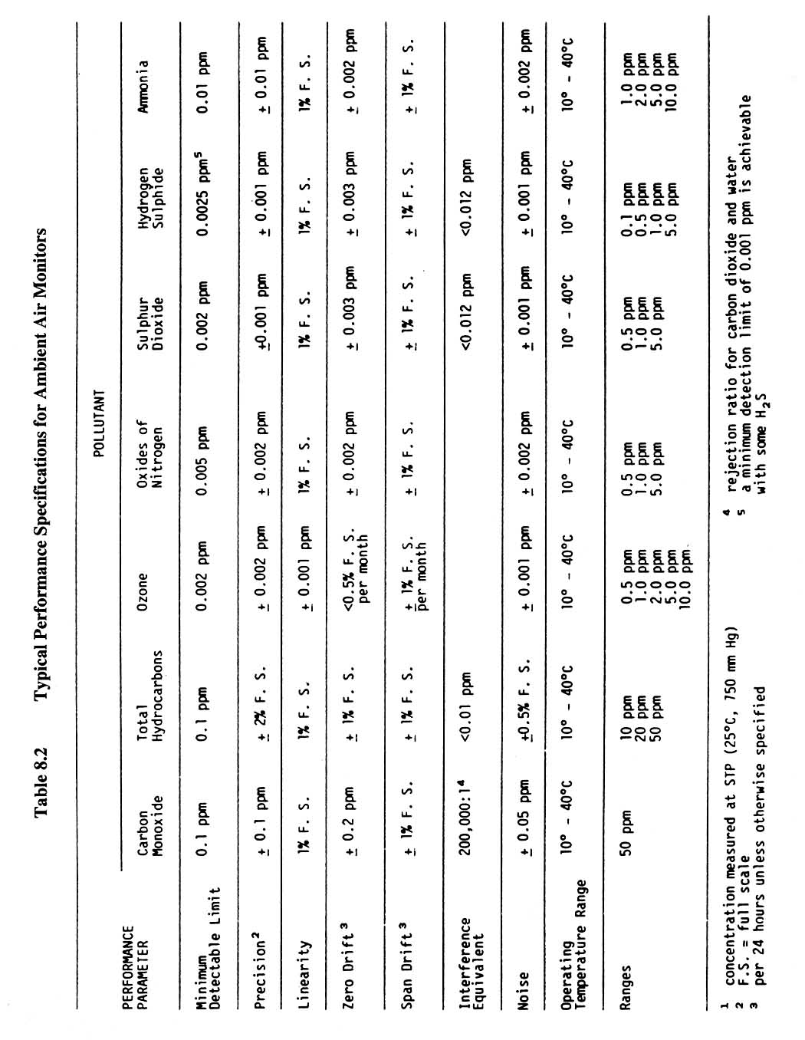

The installation height of the rain shelter should follow the standard site criteria such as:
- the rain shelter should be above ground 1 to 3 m;
- election angle should be <30o from the diffusion barrier surface of the passive sampler to the top of any obstacle; and
- the distance from the obstacle should be > 10 times the obstacle height.

In general, the rain shelter should be installed properly to prevent passive samplers from being reached by animals or human beings, and being interfered by surroundings. If there are several rain shelters in one location, it is recommended to keep them separate in order to avoid air movement interference.

Passive samplers' starting and end times and date should be recorded on a field-sampling sheet. Average temperature, average relative humidity, and average wind speed during the exposure period can be obtained from local weather station or from nearby monitoring stations.

After exposure, the samplers are removed from the rain shelter, sealed in the resealable bags, put back into the protective bottle with the cap sealed using Teflon tape and returned to lab for analysis.

The concentrations of pollutants detected by the passive sampler in the atmosphere are reported as part per billion (ppb).

Unexposed and exposed passive samplers should be kept at 4ºC. The shelf life of the passive samplers is 3 months at 4ºC and one month at room temperature.

Emissions Measurements for Stationary Sources

The owner/operator should perform stationary source testing if required by permit, regulation, or bylaw according to the standardized sampling protocols and methods acceptable to the regulatory authority. The protocols also serve as a guideline for stationary emission testing survey reporting for regulatory staff, permittees, and consultants.

For stationary emission monitoring, the regulatory authority requires the use of Environment Canada or United States Environmental Protection Agency (US EPA) Source Testing Codes, unless otherwise superseded by other requirements.

Stack sampling train for particulate and contaminant sampling by impinger method should be arranged as shown in Figure 8.2.

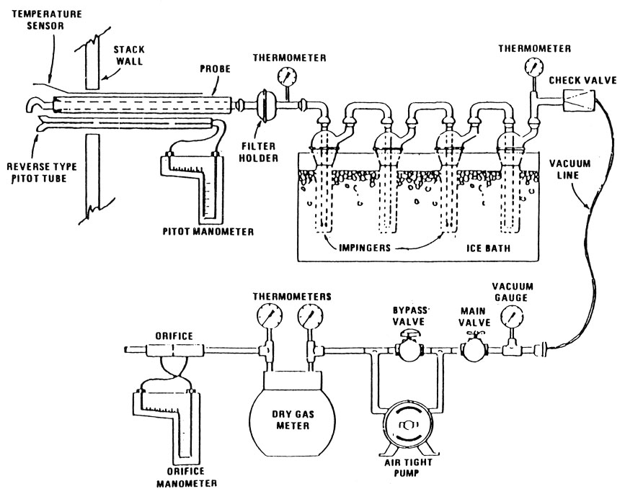

Figure 8.2 Stack sampling train for particulate and gaseous contaminants.

Summary of the EPA Source Testing Codes for Stationary Sources (US EPA), including stacks, flares and vents and Alberta Environment Stack Sampling Code (AEPA) for contaminants discharged by upstream oil and gas industry are as follows.

Measurement | Traverse Points
Methods | US EPA and AEPA Method 1.
Principle | To aid in the representative measurement of pollutant emissions and /or total volumetric flow rate from stationary source.
Applicability | This method is applicable flowing of gas streams in ducts, stacks, and flues.
Measurement | Stack Gas Velocity & Flow Rate
Methods | US EPA and AEPA Method 2.
Principle | The average gas velocity in a stack is determined from the gas density and from measurement of the average velocity head with a type S Pitot tube.
Applicability | This method is applicable for measurement of the average velocity of gas stream and for quantifying gas flow.
Measurement | Stack Gas Molecular Weight
Methods | US EPA and AEPA Method 3.
Principle | This method is applicable for determining carbon dioxide and oxygen concentrations and dry molecular weight of a sample from a gas stream of a fossil-fuel combustion process.
Applicability | Other methods, as well as modifications to the procedure, are also applicable for some or all of the above determinations.
Measurement | Moisture Content
Methods | US EPA and AEPA Method 4.
Principle | A gas sample is extracted at a constant rate from the source. Moisture is removed from the sample stream and determined either volumetrically or gravimetrically.
Applicability | The accurate determinations of moisture content as needed to calculate emission data.
Measurement | Sulphur Dioxide (SO₂)
Methods | US EPA Method 6 & 8 and AEPA Method 8.
Principle | A gas sample is extracted from a sampling point in the stack, the sulphuric acids mist and the sulphur dioxide are separated. The sulphur dioxide portion is measured by the barium-thorium titration method.
Applicability | This method is applicable for the determination of sulphuric acid mist and sulphur dioxide emissions from stationary sources.
Range and Sensitivity | US EPA Method: The minimum detectable limit is 3.4 mg/m³  (2.12 x 10⁻⁷ lb/ft³). Although no upper limit has been established, tests have shown that concentrations as high as 80,000 mg/m³ of SO₂ can be collected efficiently in two midget impingers containing 15 ml of 3% hydrogen peroxide, at a rate of 1.0 lpm for 20 min.  AEPA Method: The minimum detectable limit is 1.2 mg/m³  (0.74 x 10⁻⁷ lb/ft³, 0.46 ppm). No upper limit has been established. Based on theoretical calculations for 200 ml of 3% hydrogen peroxide solution, the upper concentration limit for SO₂ in a 1.0m³ (35.3 ft³) gas sample is about 12,500 mg/m³ (7.7 x 10⁻⁴ lb/ft³, 4800 ppm).
Apparatus | Leak free diaphragm pump; dry gas volume metre; vacuum gauge; barometer accuracy ± 2.5 mm Hg (0.1 in Hg); Pitot tube; borosilicate, Teflon or quartz probe liner with a heating system; filter holder; borosilicate glass (not needed for SO₂ determination). Impingers: four, of Greenburg – Smith design. Temperature gauge ± 1ºC. Silica gel: to dry the gas leaving the impingers. Wash bottles, graduated cylinder, and storage bottles.
Measurement | Hydrogen Sulphide (H₂S)
Methods | US EPA Method 11.
Principle | Hydrogen sulphide (H₂S) is collected from a source in a series of midget impingers and absorbed in pH 3.0 cadmium sulfate (CdSO₄) solution to form cadmium sulphide.
Applicability | The determination of hydrogen sulphide content of fuel gas streams at petroleum refineries, gas plants, flares.
Range and Sensitivity | The lower limit of detention is 8 mg/m³ (6 ppm). The maximum of the range is 740 mg/m³ (520 ppm).
Apparatus | Leak free diaphragm pump; volume metre; dry gas metre; vacuum gauge; barometer accuracy ± 2.5 mm Hg (0.1 in Hg); Pitot tube; borosilicate, Teflon or quartz liner with a heating system; five midget impingers; temperature gauge accuracy ± 3ºC. Silica gel: to dry the gas leaving the impingers; wash bottles, graduated cylinder, storage bottles. Ice bath: to maintain absorbing solution at low temperature.
Measurement | Nitrogen Oxides (NO_{x})
Methods | US EPA and AEPA Method 7, 7A & 7C (AEPA) and 7 thru 7D (US EPA), depending on specific requirements.
Principle | A grab sample is collected in an evacuated flask containing a dilute sulphuric acid-hydrogen peroxide absorbing solution, and the nitrogen oxides, except nitrous oxide, are measured colorimetrically using the phenoldisulfonic acid (PDS) procedure.
Applicability | The measurement of nitrogen oxides emitted from stationary sources.
Range and Sensitivity | The range has been determined to be 2 to 400mg NO_{x} (as NO₂) per dry standard cubic metre (std.m³), without having to dilute the sample.
Apparatus | Pump providing 75 mm Hg (3 in Hg) absolute vacuum; vacuum gauge; barometer accuracy ± 2.5 mm Hg (0.1 in Hg); Borosilicate, Teflon, or stainless steel probe with a heating system if needed. Two-liter borosilicate, round bottom collection flask with short neck. Temperature gauge accuracy ± 1ºC; in-stack or out-stack filter for removal of particulate matter. Volumetric pipette, flask valve, stopcock and Ground joint grease.
Measurement | Carbon Monoxide (CO)
Methods | US EPA 10 thru 10B and AEPA Method 10, depending on specifications.
Principle | An integrated or continuous gas sample is extracted from a sampling point and analyzed for carbon monoxide content using a nondispersive infrared analyzer (NDIR) or equivalent.
Applicability | The determination of carbon monoxide emissions from stationary sources only when specified by the test procedures for determining compliance with new source performance standards.
Range and Sensitivity | Detection range from 0 to 1,000 ppm. Minimum detectable concentration is 20 ppm for a 0 to 1000 ppm span.
Apparatus | Leak free diaphragm pump; stainless steel or sheathed Pyrex glass probe equipped with a filter to remove particulate matter; air cooled condenser or equivalent; needle valve or equivalent; rotameter or equivalent rate metre to measure a flow range from 0 to 1.0 L/min (0.035 cfm).
Measurement | Gaseous Organic Compounds (VOC)
Methods | US EPA and AEPA Method 18.
Principle | The method is based on separating the major components of a gas mixture with a gas chromatograph (GC) and measuring the separated components with a suitable detector.
Applicability | The method applies to approximately 90% of the total gaseous organics emitted from an industrial source. It does not identify and measure trace amounts of organic compounds, such as those found in building air and fugitive emission sources.
Range and Sensitivity | The range of this method is from about 1ppm to the upper limit governed by GC detector saturation or column overloading. The upper limit can be extended by diluting the stack gases with an inert gas or by using smaller gas sampling loops.
Apparatus | Leak free diaphragm pump; stainless steel or sheathed Pyrex glass probe equipped with a filter to remove particulate matter; needle valve or equivalent; rotameter or equivalent rate metre to measure a flow range from 0 to 1.0 L/min (0.035 cfm); Tedlar or aluminized Mylar sample bag 5 – 10 L volume; rigid air tight evacuated container “lung” type; S-type Pitot probe; manometer.
Measurement | Volatile Organic Compounds (Leaks)
Method | US EPA Method 21
Principle | A portable instrument is used to detect VOC leaks from individual sources. This procedure is intended to locate and classify leaks only, and is not to be used as a direct measure of mass emission rates from individual sources.
Applicability | This method applies to the determination of volatile organic compound (VOC) leaks from process equipment. These sources include but are not limited to, valves, flanges and other connections, pumps and compressors (including seal system degassing vents), pressure relief devices, process drains, open-end valves, accumulator vessel vents, agitator seals, and access door seals.
Range and Sensitivity | Both linear response range and the measurable range of the instrument for each of the VOC to be measured, and for the VOC calibration gas shall encompass the leak definition concentration specified in the relevant regulation. The response factor must be determined for each compound that is to be measured, either by testing or from reference sources. The calibration precision must be equal to or less than 10% of he calibration gas value.
Apparatus | Monitoring instrument: an acceptable detector type includes catalytic oxidation, flame ionization, infrared absorption, and photoionization. The scale of the instrument metre shall be readable to ± 2.5% of the specified leak definition concentration when performing a no detectable emission survey. The instrument shall be equipped with an electrical pump to insure that a sample is provided to the detector at a constant flow rate of 0.10 to 3.0 LPM when the probe is fitted with a filter, and the probe extension for sampling do not exceeds ¼ inch in outside diameter.

The owner/operator should assure that the following pre-test conditions are met:

- For sources that operate under permit, approval or bylaw, the owner or operator should provide the regulatory authority with a minimum of ten working days advance notice before any emission compliance testing is carried out.

- The results of all air emission testing performed for regulatory compliance requirements under permit, approval, regulation or bylaw should be retained by the facility, for a period of five years, and be made available to the regulatory authority upon request.

- A detailed test plan should be submitted in writing for approval for any nonroutine testing programs 30 days prior to the scheduled sampling.

- A minimum of three test runs constitute a valid stack survey, unless the method being used specifically states otherwise; where less than three runs are being used, the Stack Emission Survey Report should quote the reference that allows exception from the three test run requirement

- For a valid stack survey, the individual test runs should be taken on the same day; the duration, over which the three test runs are extracted should not exceed two days.

- The results of individual test runs and the average of all test runs constituting a valid stack survey should be reported; the arithmetic average of all test runs taken during a valid stack survey shall be used to assess compliance with the limits stated in permits, approvals, regulations or bylaws.

- The minimum duration of one complete test run must be 60 minutes.

- The sampling nozzle shall be sized to obtain a sample volume of 1 m³ (as sampled) or greater for particulate testing.

- Sample points shall be calculated using the applicable tables or computer programs developed with reference to EPS 1/RM/8 or the US EPA CFR 40 Part 60.

- In the recovery procedure for a standard particulate test, acetone and deionized water must be used for washing the interior surfaces of the nozzle, probe, cyclone (if used), and filter holder (the front half of the sampling train).

- Leak checks are mandatory and should be carried out as outlined in the Stack Sampling Code.

The owner/operator should provide a safe access to the sampling location and a firm sampling platform meeting specifications as detailed in Figure 8.3.

High volume particulate sampling is considered to be non-standard and requires prior written approval from the regulatory authority.

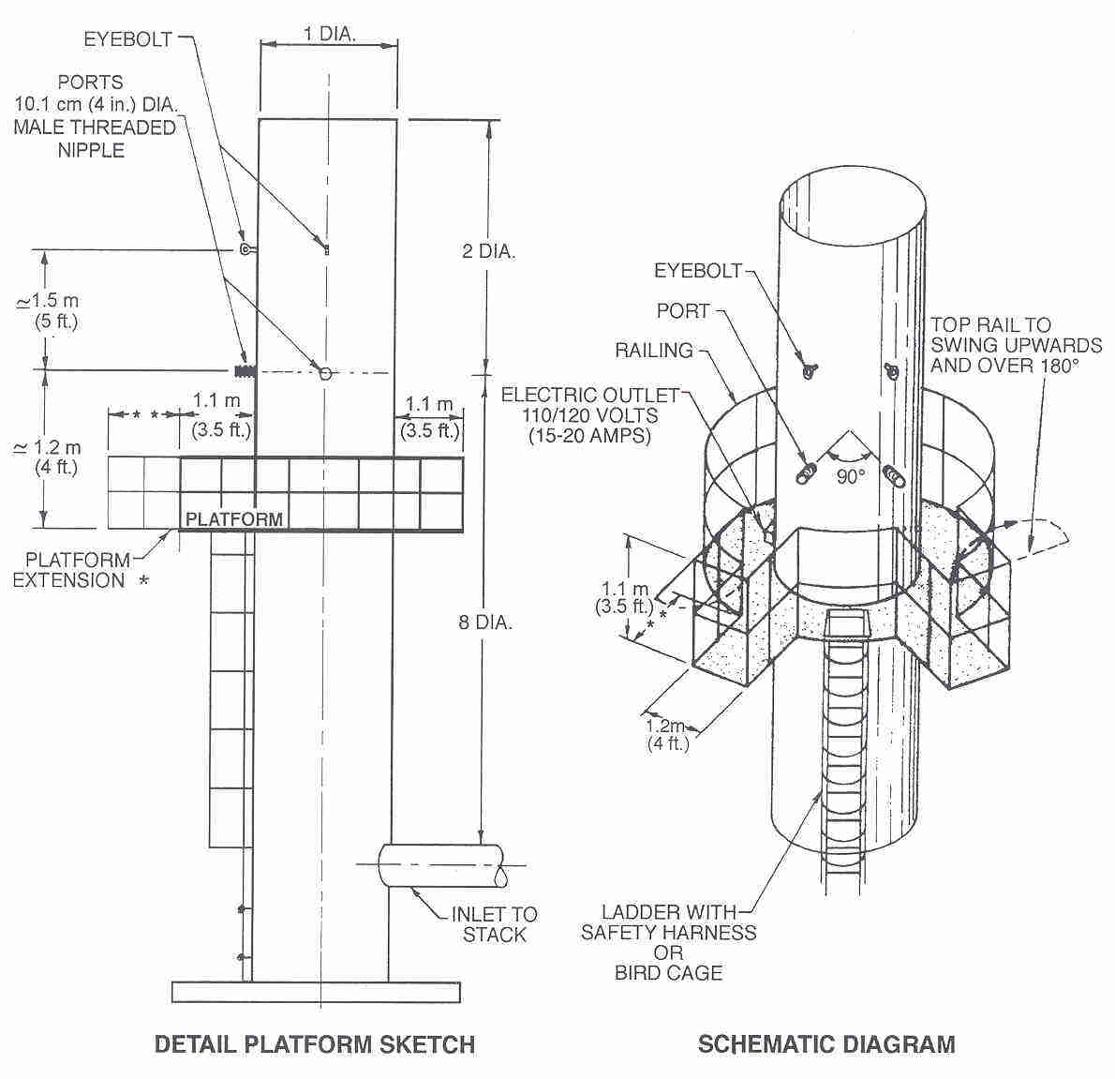
Figure 8.3 Sampling platform specifications.

Continuous Emission Monitoring System

A Continuous Emission Monitoring System (CEMS) might be required by the regulatory authority in certain circumstances for either continual compliance determination or determination of exceedances of the standards.

The owner or operator shall implement CEMS in line with standard industrial requirements that are used in other jurisdictions subject to approval by the regulatory authority. This may include the 1992 Canadian Council of Ministry of the Environment (CCME) guidelines for gas turbines if applicable and the 1998 Alberta CEMS Code which is enclosed as Appendix E.

The operator should perform periodic performance evaluations of the equipment, including daily calibration error tests, daily interference tests for flow monitors, and semi-annual (or annual) relative accuracy test audit (RATA) and bias tests.

The owner or operator should develop and implement a written quality assurance/quality control plan for each system. The quality control plan should include complete, step-by-step procedures and operations for calibration checks, calibration adjustments, preventive maintenance, audits, and record-keeping and reporting. The quality assurance plan should include procedures for conducting periodic performance tests.

The owner or operator of a unit should conduct certification tests and submit the results to the appropriate regulatory authority which would include:
- a 7-day calibration error test for each monitor;
- linearity check for each pollutant concentration monitor;
- relative accuracy test audit (RATA) for each monitor;
- bias test for each pollutant concentration monitor, flow monitor, and the CEM system;
- cycle time test for each pollutant concentration monitor; and
- daily interference test for flow monitors.

The regulatory authority will issue a notice approving or disapproving the request for certification within 90 days after receiving a complete certification application. If the proposed system is disapproved, the owner or operator should revise the equipment, procedures, or methods as necessary and resubmit a request for certification.

Reports for continuous emission monitoring surveys should include:
- a detailed sampling system description and schematic diagram;
- copies of digital or chart recorder printouts labelled with individual test start and finished time, chart speed, pre- and post calibrations, span, drift determination, parameters sampled, number of sample points, and NO_{x} converter efficiency if tested; and
- tables for analysis for calibration gases, analyzer calibration data, and system calibration bias and drift test.

Additional Information

Additional information concerning measurement and reporting is available at:

- Alberta Environment Alberta Stack Sampling Code. Publication Ref: 89.

- The U.S. Environmental Protection Agency. Title 40, Chapter 1: The Code of Federal Regulations. Part 60 - Standards of Performance for New Stationary Sources.

- Alberta Environment. Air Monitoring Directive: Monitoring and Reporting Procedures for Industry. Environmental Protection Services, Standards and Approvals Division, Edmonton, AB. June 1989.

MODELLING REQUIREMENTS

Introduction

Dispersion models are one of the primary tools used in air quality analysis in oil and gas industry. These models estimate the ambient concentrations that will result from proposed source emissions. Models are applied to estimate the ambient concentrations resulting from the combined impacts of proposed and existing sources of air contaminants. The estimated concentrations indicate if ambient air quality objectives are met and if any changes in ambient concentrations of air pollutants would occur. They play a role in determining levels of significance with respect to monitoring requirements in oil and gas industry.

A dispersion model is a series of equations describing the relationships between the concentration of a substance in the atmosphere arising at a chosen location, the release rate, and factors affecting the dispersion and dilution in the atmosphere. The model requires information on the emission characteristics and the local meteorology. Models predict future scenarios, short-term episodes, and long-term trends.

In the event of an upset condition at an upstream oil or gas facility, flaring of large volumes of gas can occur in a short period of time. Designing emergency flare stacks so that Ambient Air Quality Guidelines are met can be difficult since certain parameters, such as duration and flow rates, will vary depending on the nature of the emergency or upset flaring event. In such event, dispersion modelling can assist to account for the likelihood of upset flaring during a period of specific meteorological conditions, including worst-case meteorology.

To assist the developer in choosing between available modelling alternatives and to perform and present air quality analyses in a manner preferred by the regulatory authority, this Section has been developed to ensure that the best available tools would be used, consistency in modelling exercise is maintained and the results allow for comparison between different facilities. Soil and vegetation sampling might be required to validate the results of the dispersion modelling.

Baseline or background testing should be conducted before the facility operates.

Modelling Requirements

The requirements for modelling vary depending upon the types and amounts of pollutants emitted by the source, and the geographical location of the source within the regions.

Dispersion modelling may be required for the following reasons:

- On the request of the regulatory authority as part of the company application for approval to operate a facility which will discharge air contaminants.

- On the request of the regulatory authority when the company applies for permit renewal.

- Estimating emergency flare stack height which will assure compliance with Ambient Air Quality Objectives.

- Estimating significant impact area and obtain distribution of ground level concentrations around emissions source for environmental impact assessment (EIA).

- Addressing concerns of the public.

Obtaining Models and Resources

Dispersion modelling computer programs can be purchased from commercial suppliers or by downloading them from the US EPA Support Center for Regulatory Air Models site at the Internet site: www.epa.gov/ttn/scram/

Meteorological data required by advanced models can be purchased from Environment Canada, Atmospheric Services.

Following atmospheric dispersion models are recommended:
  - the SCREEN3 model for preliminary analysis to determine impact area, or to demonstrate that a source has no significant impacts outside the property boundary;
  - the Industrial Source Complex Short Term model ISCST3 for refined assessment;
  - the AERMOD model for advanced dispersion modelling in a complex terrain; and
  - other models may be used as necessary on a case by case basis.

Detailed model operations guidelines are available at operational manuals which are supplied with a purchased model and at a variety of Internet sites such as
  - EPA: www.epa.gov/ttn/scram/;
  - Lakes Environmental (commercial supplier): www.lakes-environmental.com; and
  - Alberta Environment: www3.gov.ab.ca/env/air/airqual/airmodelling.html.

Screening Assessment

A screening assessment should be performed with the SCREEN3 air dispersion model. It is designed for analyzing single-source release scenarios in simple or complex terrain. SCREEN3 enables users to prepare an initial screening analysis to establish a conservative or worst-case estimate of short-term air quality impacts from a specific source. The model can analyze the wide variety of scenarios which includes:
  - Sources: SCREEN3 is designed to model single-source scenarios. Point, area, and volume sources, as well as release from flares, can be analyzed;
  - Terrain: SCREEN3 can model flat, simple, or complex (above stack height) terrain, or a combination of simple and complex terrain;
  - Receptors: SCREEN3 allows for both automated receptor arrays and discrete receptors to be used in a model run. Discrete receptors can be entered with a height above ground level (flagpole receptors), except in complex terrain situations; and
  - Meteorological Data: A matrix of 54 combinations of wind speed and stability class can be analyzed in a single model run to determine which meteorological conditions produce highest downwind concentrations. Discrete wind speed and stability class categories can also be entered directly into SCREEN3. For complex terrain analyses, SCREEN3 uses VALLEY screening conditions (2.5 m/s, F stability class).

In addition to the above scenarios, SCREEN3 has the ability to account for the effects of building downwash and can calculate concentrations in building cavity regions. SCREEN3 is also unique among EPA models because it can incorporate the effects of inversion break-up and shoreline fumigation.

Default options of the model include:
  - stack tip downwash;
  - final plume rise;
  - buoyancy induced dispersion;
  - the vertical potential temperature gradient;
  - treatment for calms; and
  - appropriate wind profile exponents.

The operator should provide the following model input data:

- For stack modelling
- pollutant emission rate (g/s);
- stack height (m);
- stack internal diameter (m);
- exhaust exit velocity (m/s) and temperature (K);
- ambient temperature (K); and
- receptor height above ground.

- For flare modelling
- pollutant emission rate (g/s);
- flare stack height (m);
- total heat release rate (cal/s);
- receptor height above ground; and
- the model assumes flare stack temperature of 1273 K and an exit velocity of 20 m/s.

Following modelling options are available:
  - source type: stack, flare, area, or volume;
  - urban or rural area;
  - full meteorology or single stability class;
  - building downwash;
  - complex, flat or elevated terrain;
  - automatic or discrete distances; and
  - fumigation (shore line effect).

Model output includes:
  - summary of input data;
  - tabular and graphical values of concentration vs. distance at 1-hour averaging time;
  - terrain height;
  - stability class for each point of distance/concentration;
  - buoyancy and momentum fluxes; and
  - diffusion coefficients in Y and Z directions.

The concentration values (including the addition of background/existing concentrations) shall be compared with Ambient Air Quality Standards (AAQS) which are listed for common pollutants in Table 9.1. If exceedances exist, the model would be run again with individual stability classes (from A to F). Analyzing maximums in each class may indicate that no exceedances occur in all classes except for very unstable class A conditions. This is a very rare stability class so no further modelling would be necessary.

Once the modelling is completed, plots for the flaring scenario of the emission rate versus duration should be created. The amount of plots created may vary depending on the nature of the operation. At a minimum, plots for stabilities (B - unstable), (D - neutral), and (E - stable) should be made for the worst-case flaring event. This will be sufficient to give an operator an indication as to how flaring can be conducted. An example of the plots is shown in Figure 9.1 (source: Emergency / Process Upset Flaring Management: Modelling Guidance, Alberta Environment, Pub. No: 0-7785-0685-1, August 1999).

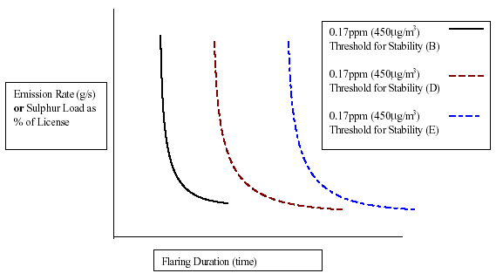

Figure 9.1 Acid Gas Flaring During Different Stability Conditions.

When these plots are completed, they should be supplied to the operators, along with a description of stability conditions. The operators will then have the ability to assess the most appropriate way to carry out the flaring, once health, safety and plant integrity considerations are under control.

Another way of lowering maximum concentrations at points of impingement for flares is to run the model with another heating value (achieved by adding lift gas) and determine the results. Repeat modelling runs adjusting the heating value until the guideline is met, or the results are satisfactory within the reasonable bounds of the flaring parameters.

If the modelling results described in Sections 9.4.8 and 9.4.9 are still higher than AAQS, a refined assessment should be performed with less conservative model ISCST3 (see Section 9.6). The modelling steps are shown in Figure 9.2 (source: Air Quality Model Guideline, Pub. No. T/564, Alberta Environment, October 2000).

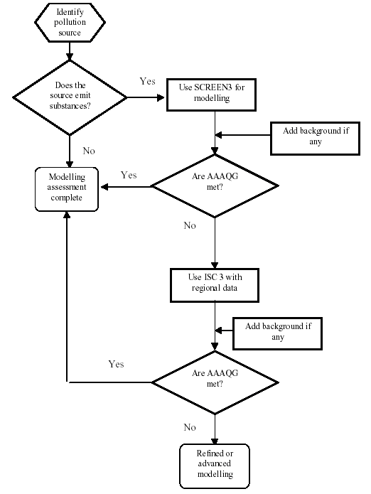

Figure 9.2 Flow chart for screen modelling tier.

Adjustment of Predictions to Shorter-Averaging Times

Two methods to convert a 1-hour concentration predicted by the model to a real time emergency or upset flaring event (e.g., less than 1 h) are proposed:

- Assume that the total gas release occurs over 10-minutes. The gas rate can be divided by 6, and modelled for the entire hour, and the resulting prediction can be directly compared with a 1 h standard.

- Assume that the gas is released over the entire hour and that the resulting concentration is what would actually occur over a 10-minute interval and take zero concentration for the rest of the hour. The resulting prediction from the model must be divided by 6 to obtain the actual 1-hour observed concentration.

Refined Assessment

The ISCST3 dispersion model is recommended for a refined assessment. The ISCST3 is a steady-state Gaussian plume model which can be used to assess pollutant concentrations and/or deposition fluxes from a wide variety of sources associated with an industrial source complex. The model was designed to support the EPA's regulatory modelling options, as specified in the US EPA Guidelines on Air Quality Models (Revised). Environment Canada and provincial Departments of the Environment consider this model a supporting tool for the ambient air quality regulations.

Some of the ISCST3 (short term) modelling capabilities are:
  - the ISCST3 model may be used to model primary pollutants and continuous releases of toxic and hazardous waste pollutants;
  - it can handle multiple sources, including point, volume, area, and open pit source types; line sources may also be modeled as a string of volume sources or as elongated area sources;
  - source emission rates can be treated as constant or may be varied by month, season, hour of day, or other optional periods of variation; these variable emission rate factors may be specified for a single source or for a group of sources;
  - it can account for the effects of aerodynamic downwash due to nearby buildings on point source emissions;
  - contains algorithms for modelling the effects of settling and removal (through dry deposition) of large particulate and for modelling the effects of precipitation scavenging - for gases or particulate;
  - receptor locations can be specified as gridded or as discrete receptors in Cartesian or polar coordinates;
  - incorporates the COMPLEX1 screening model dispersion algorithms for receptors in complex terrain;
  - the model uses real time meteorological data to account for the atmospheric conditions that affects the distribution of air pollution impacts on the modelling area; and
  - modelling results can be output for concentration, total deposition flux, dry deposition flux, and/or wet deposition flux.

The operator shall provide the following model input data for each point source:
  - pollutant emission rate (g/s);
  - stack height (m);
  - stack internal diameter (m);
  - stack location;
  - Universal Transverse Mercator (UTM) coordinates should be used for all ISCST3 modelling, i.e. source locations, receptor locations, property boundaries, etc;
  - exhaust exit velocity (m/s) and temperature (K);
  - ambient temperature (K); and
  - receptor height above ground.

Following modelling options are available:
  - source type: point, line, flare, area, open pit, volume;
  - urban or rural environment;
  - site-specific meteorological conditions;
  - building downwash;
  - terrain elevations for receptors based on imported digital elevation fields;
  - automatic or discrete distances;
  - fumigation (shore line effect);
  - regulatory default / non-default options;
  - results as concentration in air, dry deposition, wet deposition, total deposition; and
  - various averaging periods from 1 hour to multiple years.

Five years of site specific meteorological data is preferred, if available. If 5 years of site specific data is not available but more than one year is, all available site specific data is preferred for the modelling analysis. If less than 1 year of site specific data is available, 5 years of meteorological data from Environment Canada, Atmospheric Services, should be used for the modelling analysis and any site specific data available should be included.

Model output will include:
  - summary of input data;
  - tabular values of concentration vs. distance and graphical concentration isopleths at selected averaging time in 2D or 3D frames;
  - stability class for each point of distance/concentration; and
  - buoyancy and momentum fluxes.

If the predicted ambient ground level concentrations are greater than the maximum acceptable AAQS listed in Table 9.1, the owner/operator will have to undertake corrective measures that would result in lower ambient concentrations. These measures may include stack height increase, reduction of emission rate, introduction of emission control equipment, dilution with the ambient air, etc. While under certain circumstances, dilution through stack height increase may be an option. RWED would prefer to see the emphasis placed on pollution prevention solutions, best management practices, and/or improved emission controls.

Hazardous Air Pollutants (HAPs) and Toxic Chemical Substances (TCS)

The regulations frequently require modelling for HAPs and TCS for which no standards exist. The GNWT might adopt any standards and regulations for HAPS as they are promulgated. If no standard exists for a pollutant for which modelling is required, a reference value of 1/42 of the Threshold Limit Value - Time Weighted Average (TLV-TWA) for a 24 hour averaging time should be used for comparison purposes. TLV-TWA values may be taken from the publication Threshold Limit Values for Chemical Substances and Physical Agents and Biological Exposure Indices.

Table 9.1 Ambient Air Quality Standards

Jurisdiction | Pollutant | Concentration  μg/m³ | Averaging  Time | Objective
Northwest Territories | TSP | 120  60 | 24 h  Annual | Max. acceptable
Northwest Territories | PM2.5 | 30 | 24 h | Max acceptable
Northwest Territories | O₃ | 130 | 8 h | Max acceptable
Northwest Territories | SO₂ | 450  150  30 | 1 h  24 h  Annual | Max. acceptable
Canada | NO₂ | 60 | Annual | Max. desirable
Canada | NO₂ | 400  200  100 | 1 h  24 h  Annual | Max. acceptable
Canada | NO₂ | 1,000  300 | 1 h  24 h | Max. tolerable
Canada | H₂S | 1 | 1 h | Max. desirable
Canada | H₂S | 15  5 | 1 h  24 h | Max. acceptable
Canada | CO | 15,000  6,000 | 1 h  8 h | Max. desirable
Canada | CO | 35,000  15,000 | 1 h  8 h | Max. acceptable
Canada | CO | 20,000 | 8 h | Max. tolerable
Canada | O₃ | 100  30 | 1 h  24 h | Max. desirable
Canada | O₃ | 160  50  30 | 1 h  24 h  Annual | Max. acceptable
Canada | O₃ | 300 | 1 h | Max. tolerable
Alberta | Benzene | 30 | 1 h | Max. acceptable
Alberta | Ammonia | 1,400 | 1 h | Max. acceptable

Submission of Modelling Results

Upon completion of dispersion modelling an Air Quality Report should be submitted to the regulatory authority. The report should contain the following:
  - introduction;
  - scope of work;
  - model selection criteria;
  - short description of the models used;
  - model input data and explanation how they were derived or obtained with sample calculations if relevant (e.g. stack testing results, emission calculations with AP42 emission factors, mass balance);
  - listing of selected options such as averaging periods, building downwash, terrain data, meteorological data;
  - the dispersion modelling results (graphs of isopleths, with background maps, percentile concentrations, concentrations summary tables, models-generated reports);
  - a summary of any exceedances identified when compared to the maximum acceptable valued defined by appropriate AAQS; and
  - any other information as required by the regulatory authority.

Additional Information

Additional information on dispersion modelling is provided in Air Quality Model Guideline, Alberta Environment, October 2000, provided in Appendix F.

REFERENCES

AENV, 2000. Air Quality Model Guideline. Pub. No. T/564. Science and Technology Branch, Environmental Services Division, Alberta Environment, October.

AEUB, 1999. Guide 60: Upstream Petroleum Industry Flaring Guide. Alberta Energy and Utilities Board, Calgary, AB.

Akin, T. and W.H. Battye, 1994. Memorandum to Martha E. Smith, U.S. Environmental Protection Agency. Environmental Consultants and Research, Incorporated. October 18. Durham, North Carolina.

APCD Policy and Procedure 6100.061, Determination of Fugitive Hydrocarbon Emissions at Oil and Gas Facilities Through the Use of Facility Component Counts, July 1996.

API, 1995. Emission Factors for Oil and Gas Production Operations. American Petroleum Institute, API Publication Number 4615. Washington, DC.

API, 1996. Calculation Workbook for Oil and Gas Production Equipment Fugitive Emissions. American Petroleum Institute, API Publication Number 4638. Washington, D.C.

API, 1998. Emissions Estimation Software. American Petroleum Institute. http://www.api.org/ehs/old%20rh/E&PTANK&EPEC.htm#EPEC. September.

Beavon, D.K. Abating Sulphur Plant Gases. Pollution Engineering, pp. 34-35, January/February 1972.

Boyer, B.E. and K. Brodnax, 1996. Oil and Gas Production Emission Factors and Estimation Methods. Complete Oil Field Management and Maintenance, Inc., Lafayette, Louisiana, and Mobil Exploration and Production Company, Houston, Texas. Presented at the Emission Inventory: Key to Planning Permits, Compliance and Reporting Conference, Air and Waste Management Association, September 4-6, New Orleans, Louisiana.

CCME, 1993. Environmental Code of Practice for the Measurement and Control of Fugitive VOC Emissions from Equipment Leaks. Pub. No. PN 1106, October.

CCME, 1994. Code of Federal Regulations (CFR), Protection of Environment, 40 CFR, Part 60, Subpart KKK, revised July.

Collett Ventures Company. Compliance Test Report. Environmental Science & Engineering, Inc., Gainesville, FL, May 1991.

Corbeille, R., 1997. Hydrogen Sulfide Occurrences in the Gulf of Mexico, Outer Continential Shelf Operations. U.S. Department of the Interior, Minerals Management Service, Gulf of Mexico OCS Regional Office, New Orleans.

Eaton, W.S. et al., 1980. Fugitive Hydrocarbon Emissions From Petroleum Operations, American Petroleum Institute, Rockwell International, March.

EPA, 1972. Federal Air Quality Control Regions, AP-102, U. S. Environmental Protection Agency, Research Triangle Park, NC, January.

EPA, 1974. Sulfur Compound Emissions Of The Petroleum Production Industry, EPA-650/2-75-030. U. S. Environmental Protection Agency, Cincinnati, OH.

EPA, 1976. Standards Support And Environmental Impact Statement, Volume 1: Proposed Standards of Performance For Petroleum Refinery Sulphur Recovery Plants, EPA-450/2-76-016a, U. S. Environmental Protection Agency, Research Triangle Park, NC, September.

EPA, 1977. Industrial Process Profiles for Environmental Use: Chapter 2, Oil and Gas Production Industry. U.S. Environmental Protection Agency, Office of Research and Development, EPA-600/2-77-023b. Cincinnati, Ohio.

EPA, 1982. Equipment Leaks of VOC in Natural Production Industry, No 450/3-82-024a.

EPA, 1983. Review of New Source Performance Standards for Petroleum Refinery Claus Sulphur Recovery Plants, EPA-450/3-83-014, U. S. Environmental Protection Agency, Research Triangle Park, NC, August.

EPA, 1995a. Compilation of Air Pollutant Emission Factors. Volume I: Stationary Point and Area Sources. Paragraph 5.3: Natural Gas Processing. Fifth Edition, AP-42. U.S. Environmental Protection Agency, Office of Air Quality Planning and Standards. Research Triangle Park, North Carolina.

EPA, 1995b. Compilation of Air Pollutant Emission Factors. Volume I: Stationary Point and Area Sources. Paragraph 8.13: Sulfur Recovery. Fifth Edition, AP-42. U.S. Environmental Protection Agency, Office of Air Quality Planning and Standards. Research Triangle Park, North Carolina.

EPA, 1995c. Protocol for Equipment Leak Emission Estimates. U.S. Environmental Protection Agency, Office of Air Quality Planning and Standards, EPA-453/R-95-017. Research Triangle Park, North Carolina.

EPA, 1995d. State Workbook, Methodologies for Estimating Greenhouse Gas Emissions, Second Edition. U.S. Environmental Protection Agency, Office of Policy, Planning and Evaluation, EPA-230-B-95-001. Washington, D.C.

EPA, 1995e. Inventory of U.S. Greenhouse Gas Emissions and Sinks: 1990-1994. U.S. Environmental Protection Agency, Office of Policy, Planning and Evaluation, EPA-230-R-96-006. Washington, D.C.

EPA, 1995f. Protocol for Equipment Leak Emission Estimates. U.S. Environmental Protection Agency, Office of Air Quality Planning and Standards, EPA-453/R-95-017. Research Triangle Park, North Carolina.

EPA, 1998. Factor Information and Retrieval System (FIRE), Version 6.01. Updated Annually. U.S. Environmental Protection Agency, Office of Air Quality Planning and Standards, Research Triangle Park, North Carolina.

Getty Oil Company. Emission Test Report. New Hope, TX. EMB Report No. 81-OSP-9, July 1981.

Goar, B. et al., 1986. Sulphur Recovery Technology. Energy Progress, Vol. 6(2): 71-75, June.

GRI. 1994. Preliminary Assessment of Air Toxic Emissions in the Natural Gas Industry, Phase I, Topical Report. Gas Research Institute, GRI-94/0268. Chicago, IL.

GRI. 1997. GRI-GLYCalc™ Version 3.0 Computer Program. Gas Research Institute. http://www.gri.org/tech/e+s/airprj.htm#aquevalmeth3

GRI. 1998. GRI-HAPCalc™ and GRI-HAPData™ Software. Gas Research Institute. http://www.gri.org/pub/content/apr/19980406/204648/hapcalc.html

Harris, G. E. et al., 1982. Frequency of Leak Occurrence and Emission Factors for Natural Gas Factors for Natural Gas Liquid Plants, EPA DCN 82-222-018-04-48, July.

Katz, D.K. et al., 1959. Handbook Of Natural Gas Engineering, McGraw-Hill Book Company, New York.

Kirk, R.E. and D. F. Othmer (eds.), 1951. Encyclopedia Of Chemical Technology. Vol. 7, Interscience Encyclopedia, Inc., New York, NY.

Maddox, R.R., 1974. Gas And Liquid Sweetening, 2nd Ed. Campbell Petroleum Series, Norman, OK.

Martino, P., 1997. Petroleum Production Emission Estimating Techniques and Software. American Petroleum Institute. Washington, D.C. Presented at the Emission Inventory: Planning for the Future, October 28-30, 1997, Research Triangle Park, North Carolina.

Mian, M.A. 1992. Petroleum Engineering Handbook for the Practicing Engineer, Volume I. PennWell Publishing Company. Tulsa, Oklahoma.

Mobil Exploration and Producing Southeast, Inc. Compliance Test Report. Coden, Alabama. Cubix Corporation, Austin, TX, September 1990.

Mullins, B.J. et al., 1975. Atmospheric Emissions Survey Of The Sour Gas Processing Industry, EPA-450/3-75-076, U. S. Environmental Protection Agency, Research Triangle Park, NC, October.

Nizich, G. and EC/R. 1999. Table 1. Comparison of Measured HAP Emissions to Emissions Predicted Using E&P TANK and EC/R Algorithm. U.S. Environmental Protection Agency, Emission Standards Division, Research Triangle Park, NC and Environmental Consulting and Research, Durham, NC, July.

Phillips Petroleum Company. Compliance Test Report. Chatom, Alabama. Environmental Science & Engineering, Inc., Gainesville, FL, July 1991.

RCD P&P V.1, Rule 331 Fugitive I&M Enforcement Guidelines. April 1993.

Rucker, J.E. and R.P. Strieter, 1992. The Petroleum Industry Air Pollution Engineering Manual, AP-40. Air and Waste Management Association. Pittsburgh, Pennsylvania.

Santa Barbara County APCD. Modelling of Fugitive Hydrocarbon Emissions. Tecolote Research Inc., January 1986.

Santa Barbara County APCD, VOC/ROC Emission Factors and Reactivities for Common Source Types. Version 1.1. of July 1998.

TNRCC. 1998a. Determination of Applicable Requirements for Pigging Operations at Marine Transfer Facilities. Texas Natural Resource Conservation Commission. http://www.tnrcc.state.tx.us/air/opd/state/115/211/irim08.htm

TNRCC. 1998b. Applicability of Vent Gas Control Rules to Pipeline Pigging Activities. Texas Natural Resource Conservation Commission. http://www.tnrcc.state.tx.us/air/opd/state/115/121/rim07.htm

